**Lab 12. 1 - Docker on Azure**

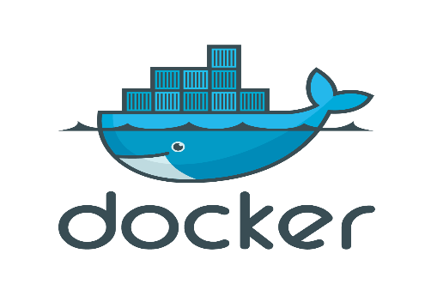

**Source: https://azuredevopslabs.com/labs/vstsextend/docker/#summar**

# Prerequisites

1. **Microsoft Azure Account:** You will need a valid and active Azure account for the lab. You can sign up for a [free trial](https://azure.microsoft.com/en-us/free/) if you do not have one
2. **Azure DevOps Account**: You will need an Azure DevOps account. You can sign up for free [here](https://azure.microsoft.com/en-us/services/devops/) if you do not have one.

# Setting up the Azure DevOps Project

**Azure DevOps Demo Generator** helps you create team projects on your Azure DevOps Organization with sample content that include source code, work items, iterations, services endpoints, build and release definitions based on the template you choose during the configuration.

**Step 1**: Browse to the [Azure DevOps Demo Generator](https://azuredevopsdemogenerator.azurewebsites.net/) site by selecting the link, or copy <https://azuredevopsdemogenerator.azurewebsites.net/> into your browser’s URL field.

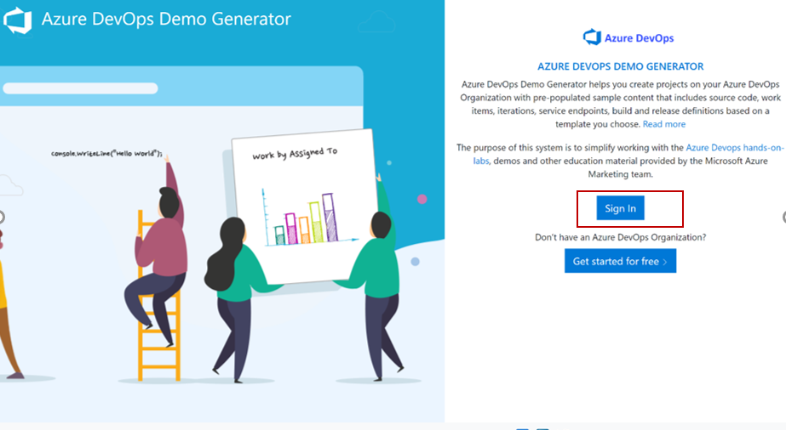**Step 2:** Click **Sign In** and provide the Microsoft or Azure AD account. You should be able to sign in with our school email.

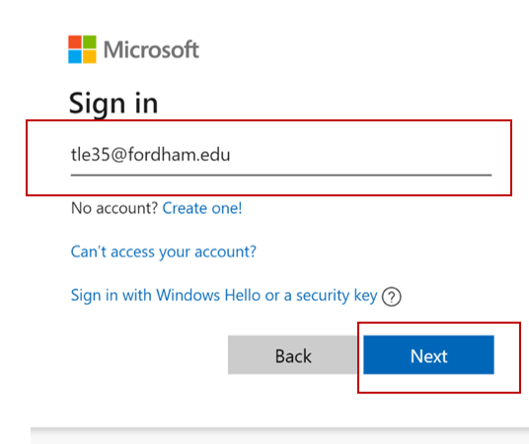

**Step 3**: After you sign in, select **Accept** to grant the Demo Generator permission to access your Azure DevOps organization.

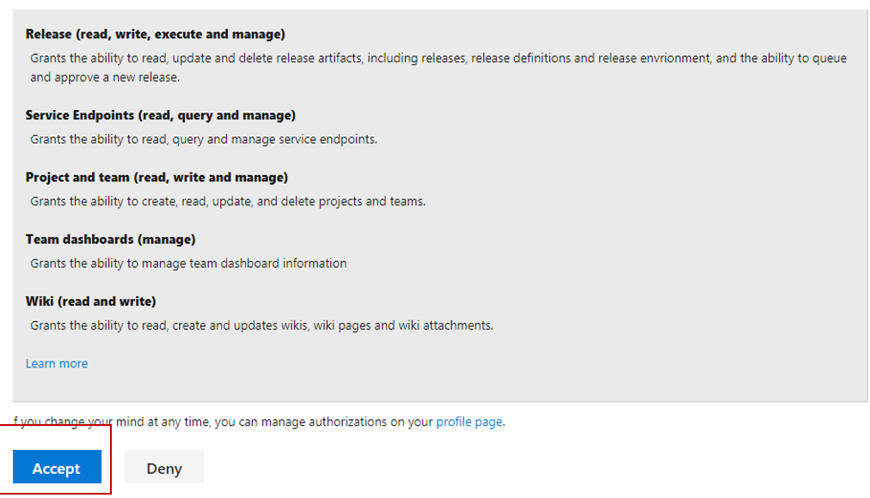

**Step 4**: Select the organization you will use to host the project created by the Azure DevOps Demo Generator. (You may have multiple accounts of which you are a member, and which are associated with your login, so choose carefully.) **Provide a name** for your project (such as "MyProjectDemo" ) that you and other contributors can use to identify it as a demo project. Lastly, **select the demo project template** you want to provision by clicking ... (Browse) button.

When you click to **choose template**, choose **DevOps Labs > Docker** then choose **Select Template**

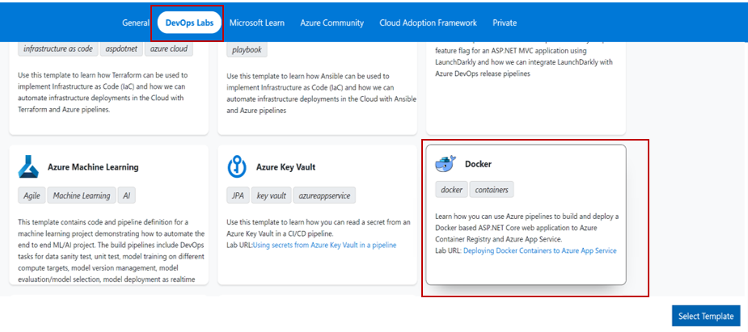

Give project a name and select Organization as your account

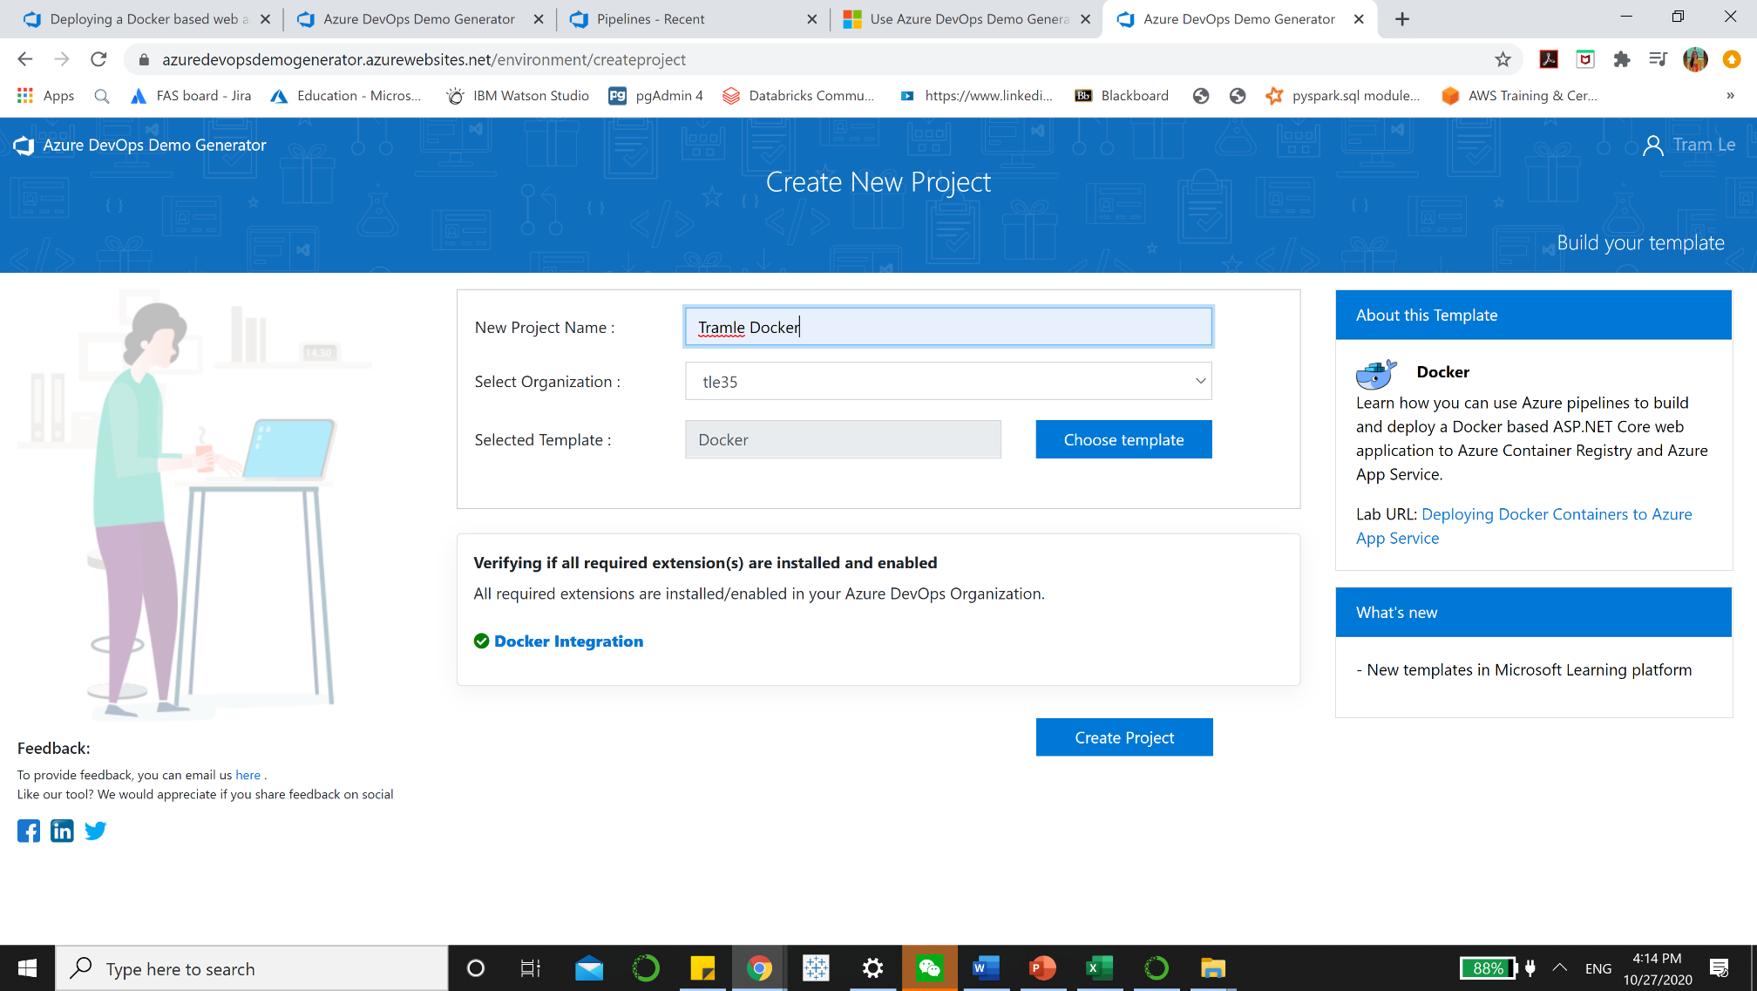

Then you can choose **Create Project**.

Note: You might run into some issue such as:

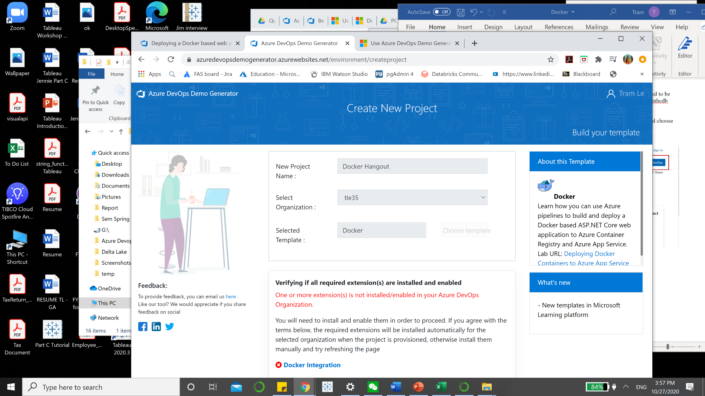

You should check the box next to this message so Azure will install all the extensions when you create your project.

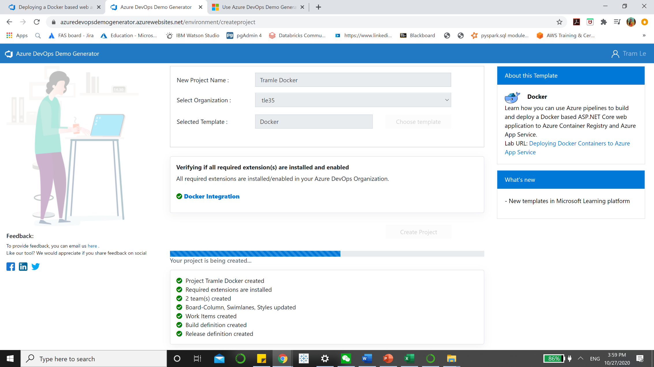

**Step 5**: Some templates may require additional extensions to be installed to your organization. The demo generation process checks to see if these extensions are already installed. If the extension is already installed, a green check will be displayed in front of the extension name. If the extension is not installed, select the empty check boxes to install the extension(s) to your account. When ready, click on **Create Project** button.

# Overview

A Docker container image is a lightweight, standalone, executable package of software that includes everything needed to run an application: code, runtime, system, tools, system libraries and settings.

This lab outlines the process to build custom Docker images of an **ASP.NET Core** application, push those images to a private repository in **Azure Container Registry (ACR)**. These images will be used to deploy the application to the Docker containers in the **Azure App Service** (Linux) using Azure DevOps.

The Web App for Containers allows the creation of custom **Docker** container images, easily deploy and then run them on Azure.

Combination of Azure DevOps and Azure integration with Docker will enable the following:

1. Build custom Docker images using Azure DevOps Hosted Linux agent
2. Push and store the Docker images in a private repository
3. Deploy and run the images inside the Docker Containers

# Deploying a Docker based web application to Azure App Service

## Setting up the Environment

The following resources needs to be configured for this lab:

* Azure Container Registry
* Azure Web App for Containers
* Azure SQL Server Database

**Step 1**: **Launch the** [**Azure Cloud Shell**](https://docs.microsoft.com/en-in/azure/cloud-shell/overview) from the Azure portal and **choose Bash**

You can do this in **two ways**, **Direct link** or **Azure portal**:

* **Direct link**: Open a browser to [https://shell.azure.com](https://shell.azure.com/)

After click on the Direct Link, you should have access to this window:

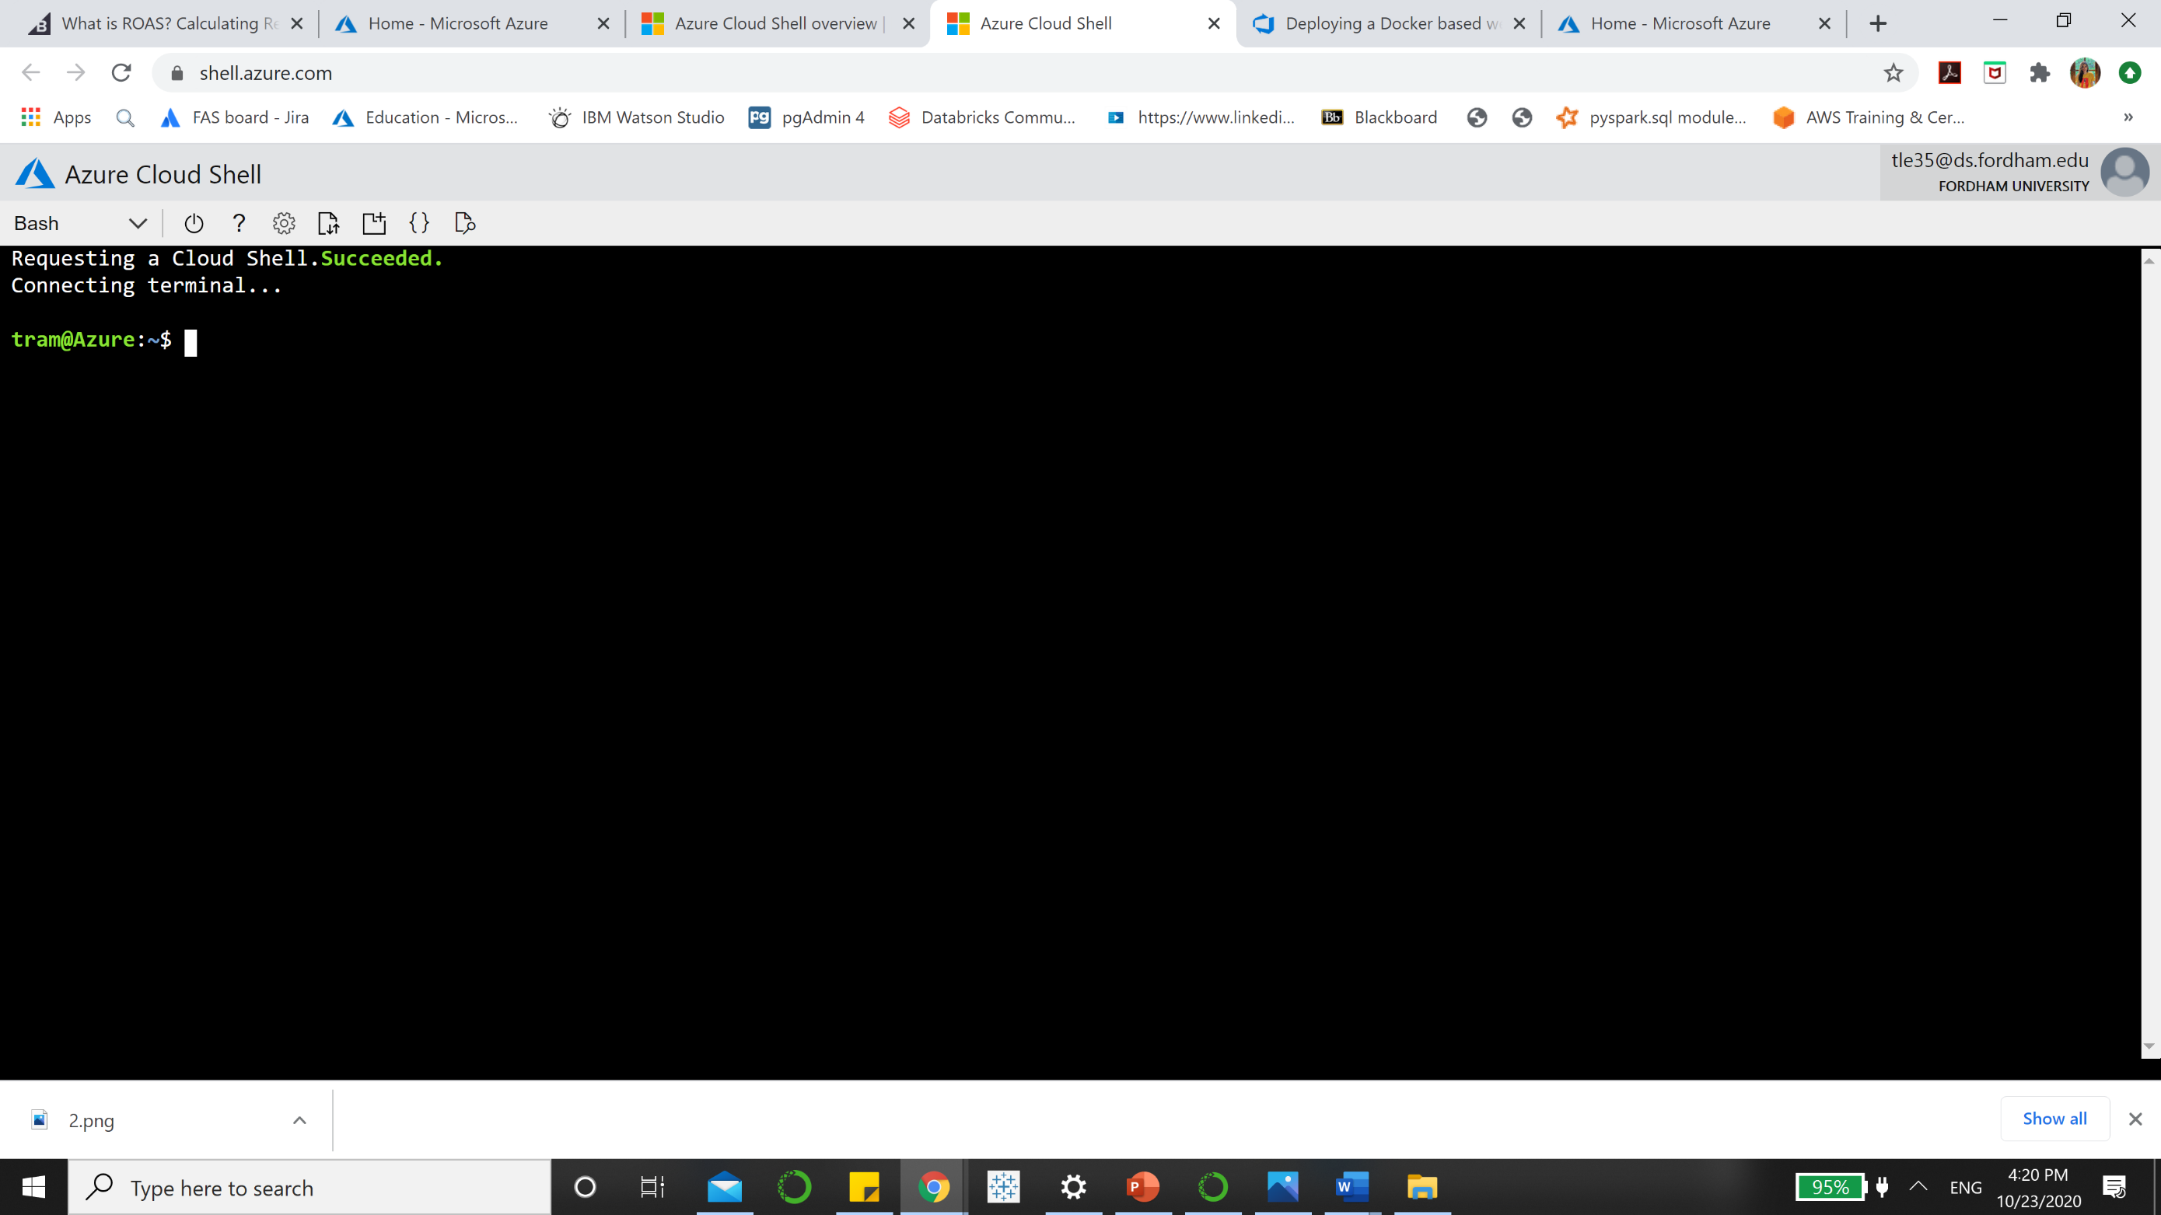

* **Azure portal:** Select the Cloud Shell icon on the [Azure portal:](https://portal.azure.com/#home) then choose **Bash.**

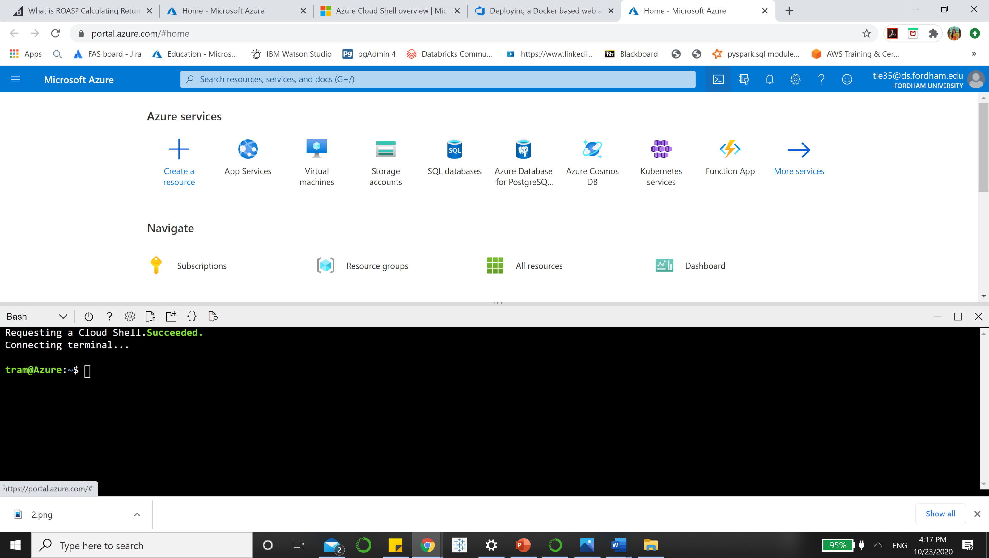

After selecting **Bash,** your window should be like this:

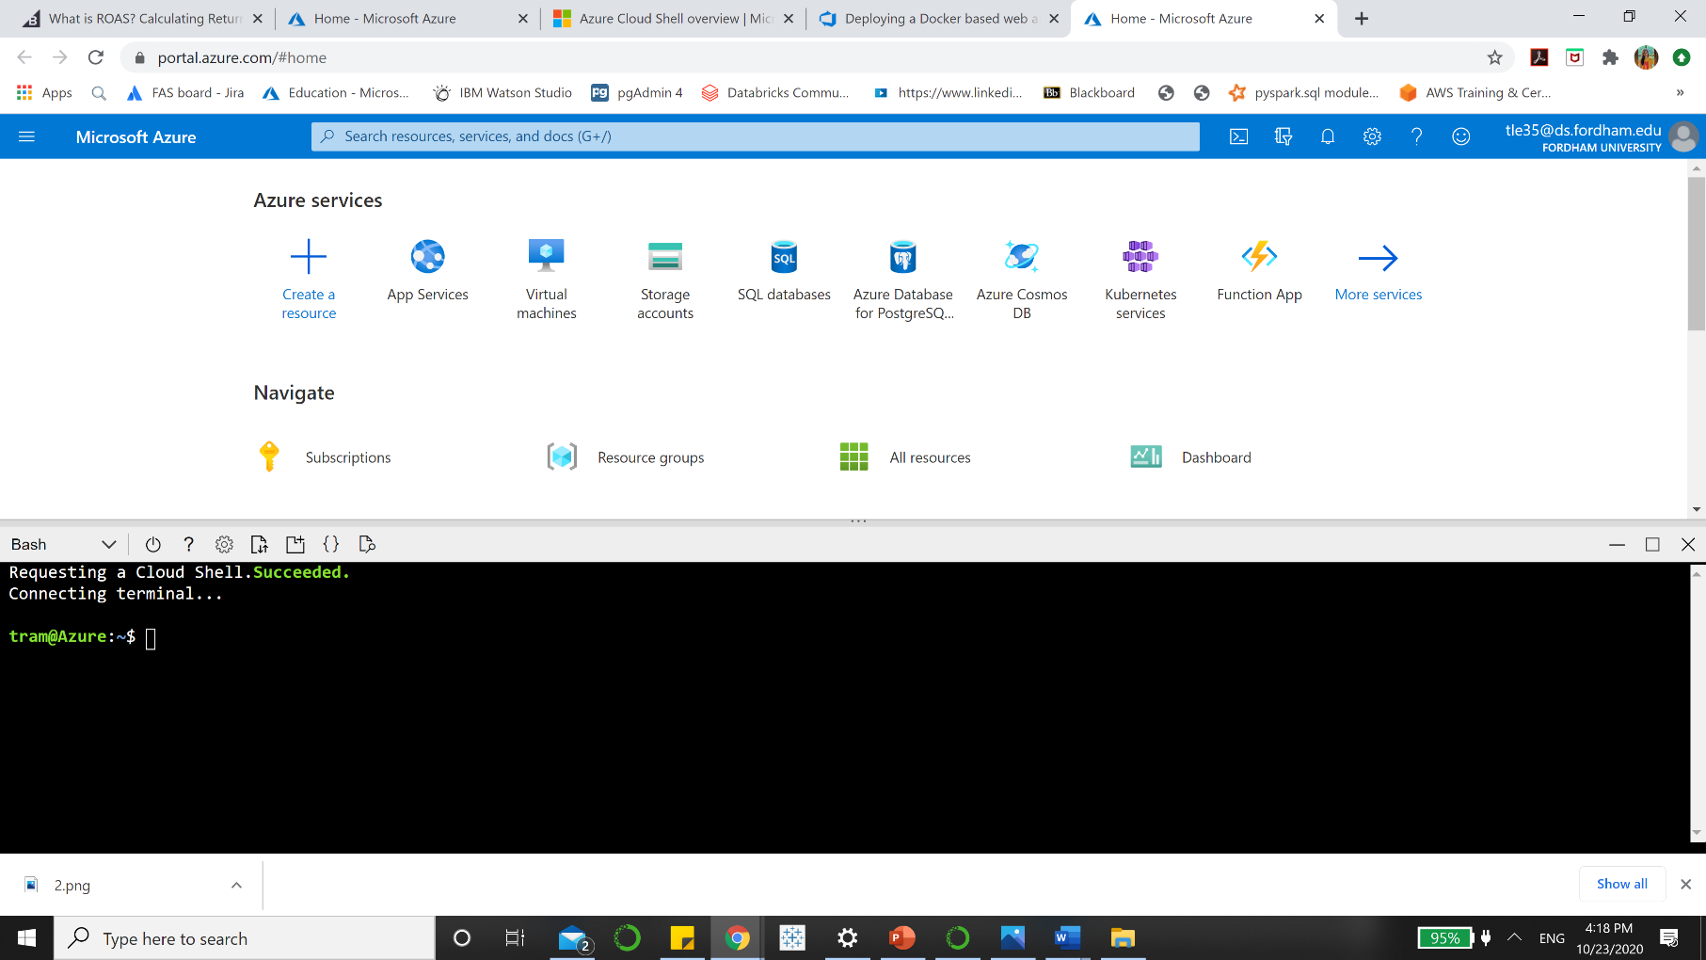

**Step 2**: Now, you want to **Create Azure Container Registry**:

## Create a Resource Group

Replace <region> with the region of your choosing, for example eastus. Remember to remove the < > when you replace. The code is as follow:

az group create --name DockerRG --location <region>

Now, you should **enter** az group create --name DockerRG –location eastus into the Bash. It should appear as the figure below.

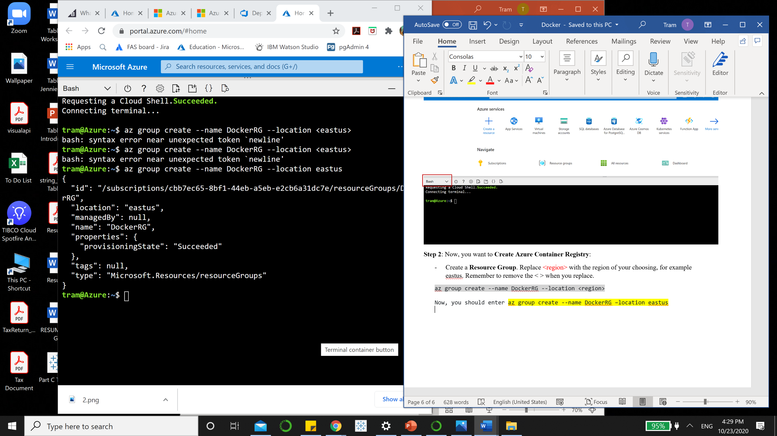

## Create ACR (Azure Container Registry)

az acr create -n **<unique-acr-name>** -g DockerRG --sku Standard --admin-enabled true

Enter this into the bash with you unique ACR name. Change **<unique-arc-name>** into a unique ACR name. ACR name may contain **alpha numeric characters only** and must be **between 5 and 50 characters**. For example, my ACR unique name would be **acrTramle1.**  Please following the format [a-zA-Z0-9]

az acr create -n acrTramle1 -g DockerRG --sku Standard --admin-enabled true

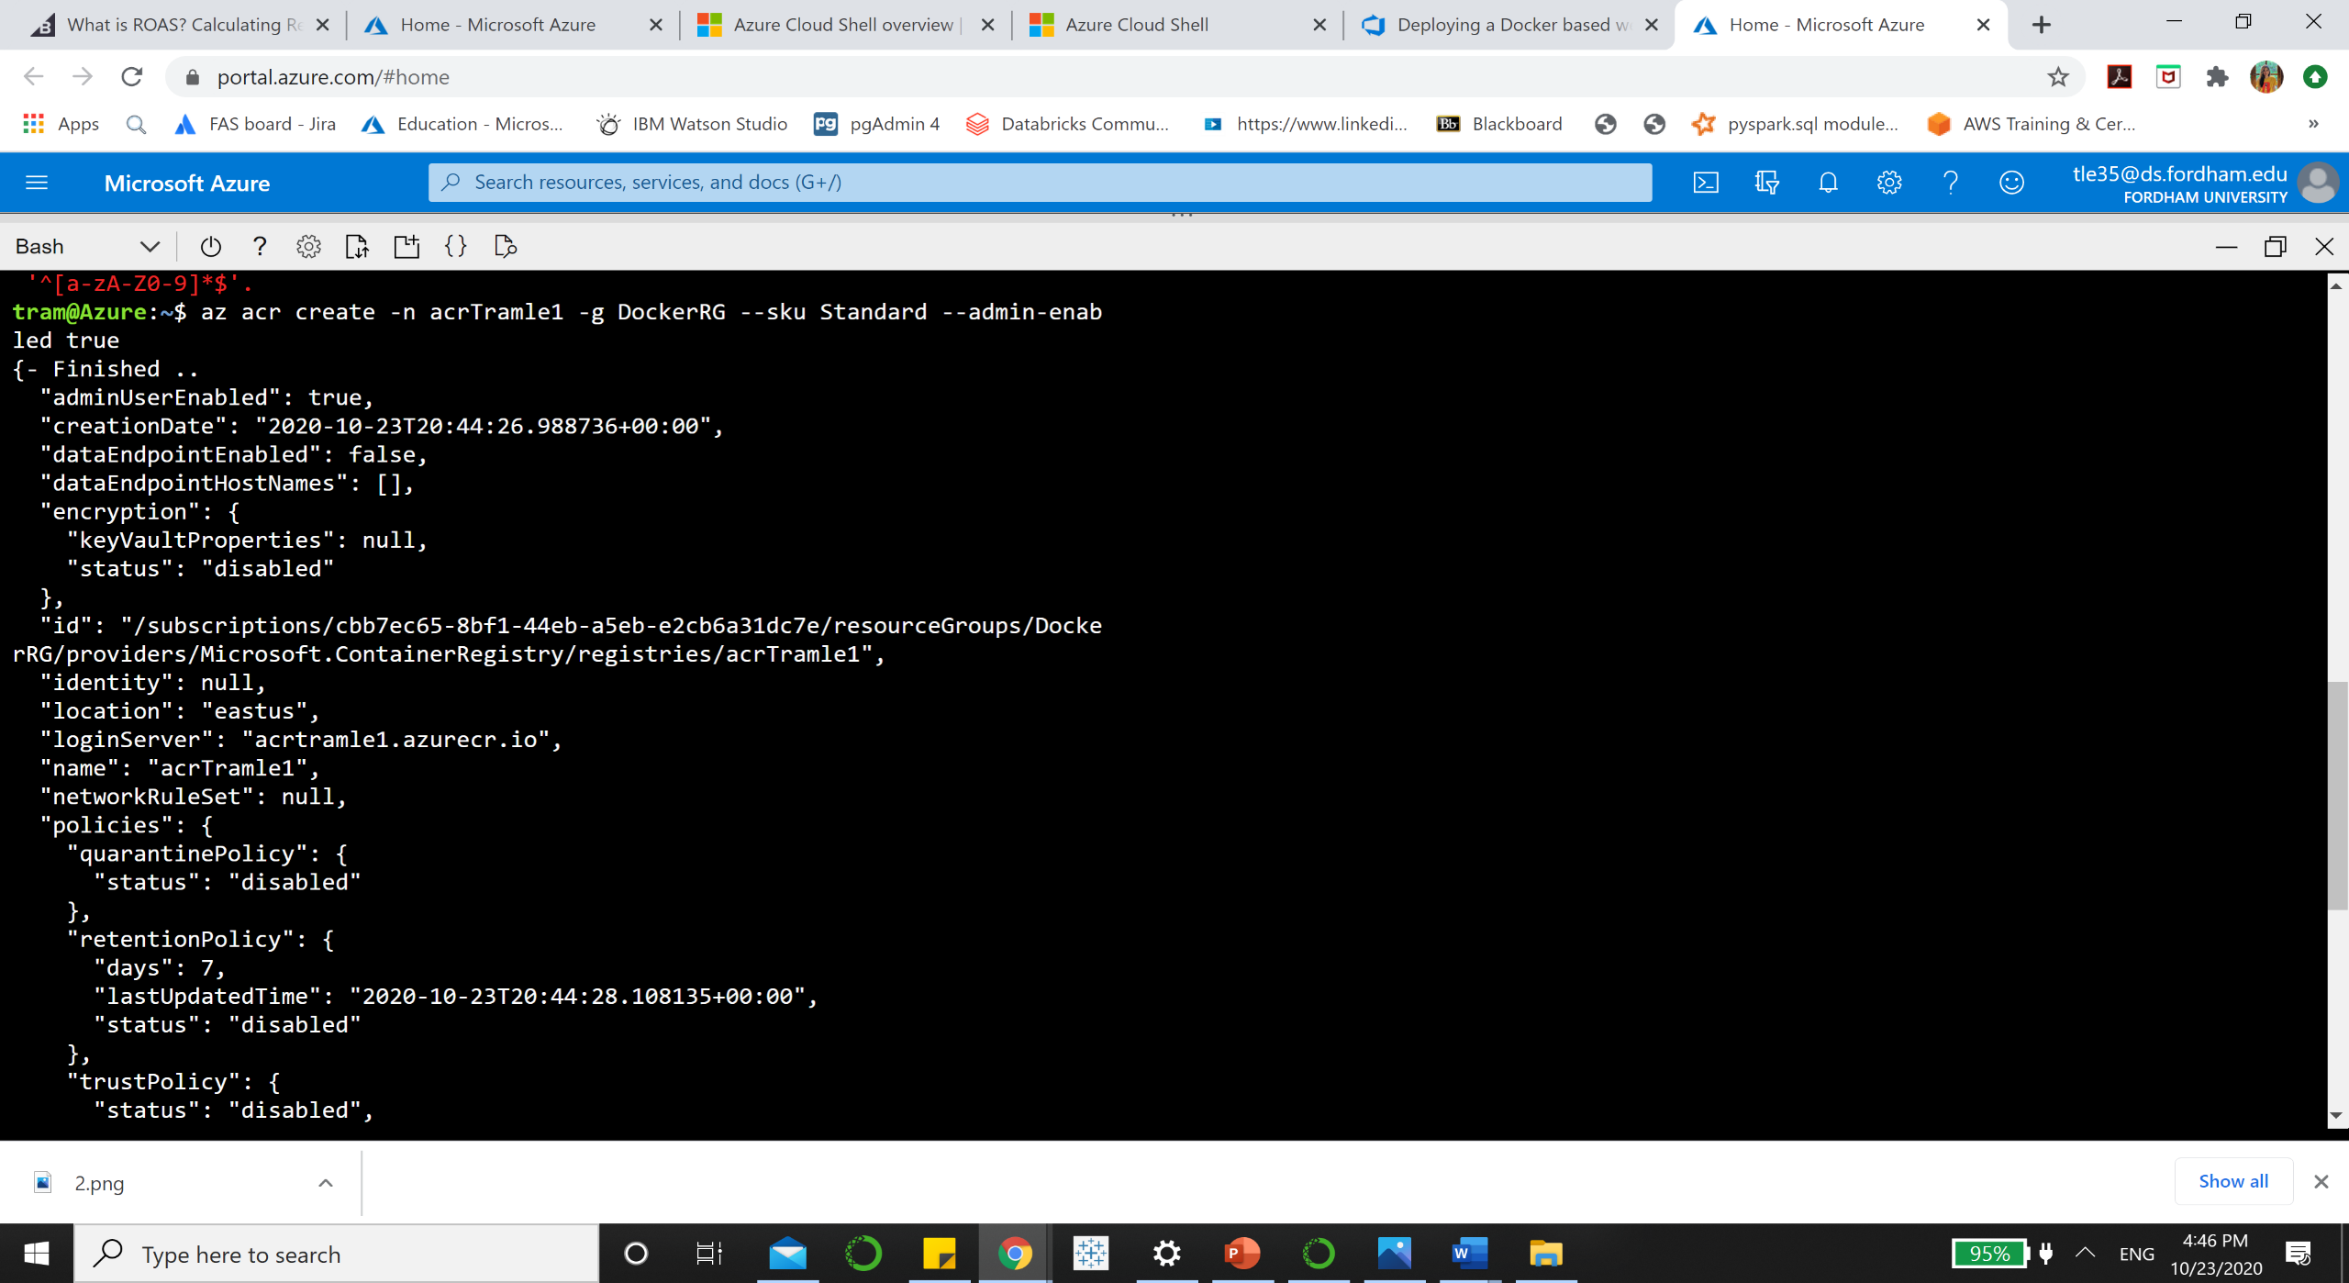

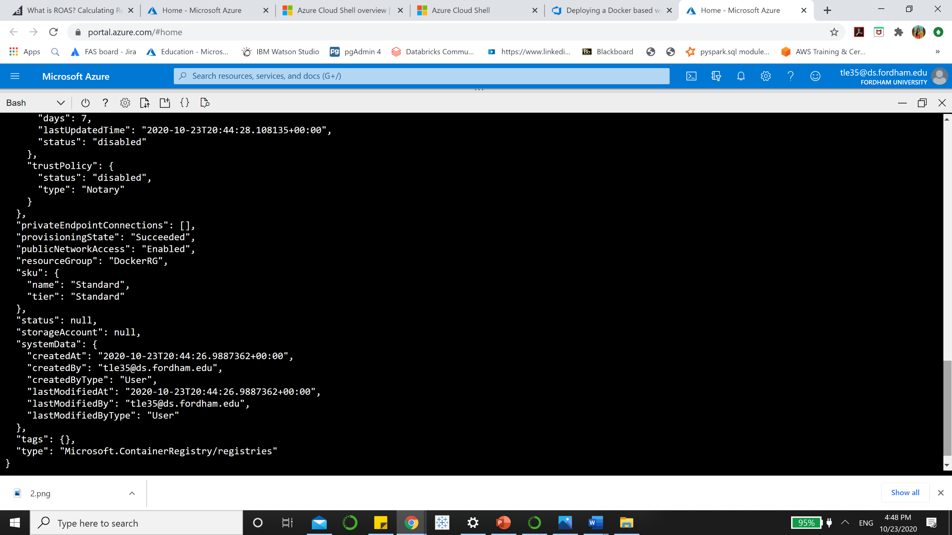

When you successfully create ACR, you should receive the window like this.

**Step 3: Create Azure Web App for Container**

* **Create a Linux App Service Plan**

az appservice plan create -n myappserviceplan -g DockerRG --is-linux

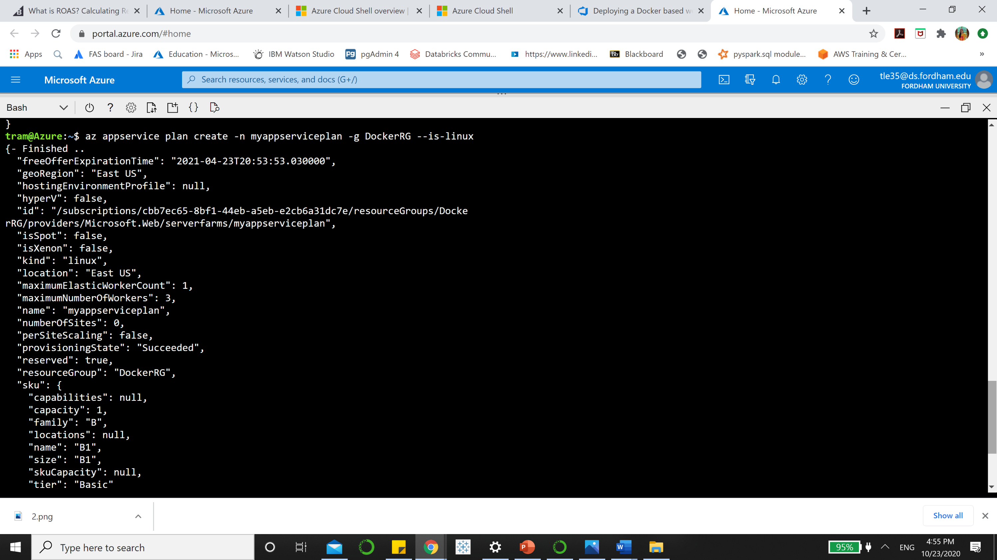

* **Create a custom Docker container Web App**: To create a web app and configuring it to run a custom Docker container, run the following command

az webapp create -n **<unique-appname>** -g DockerRG -p myappserviceplan -i elnably/dockerimagetest

You want to create a unique-appname. I will choose mine as **apptramle1**

After figure out your name, enter the code:

az webapp create -n **apptramle1** -g DockerRG -p myappserviceplan -i elnably/dockerimagetest

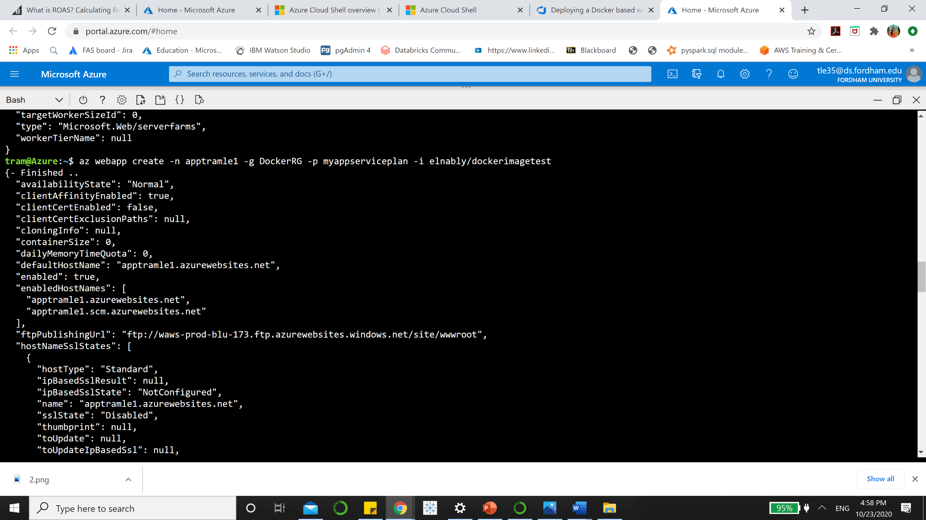

**Step 4: Create Azure SQL server and Database**

* Create an Azure SQL server

az sql server create -l <region> -g DockerRG -n <unique-sqlserver-name> -u sqladmin -p P2ssw0rd1234

Change <region> into eastus and change <unique-sqlserver-name> into your choice. My database name is tramle1(BigDataApp)

az sql server create -l eastus -g DockerRG -n tramle1 -u sqladmin -p P2ssw0rd1234

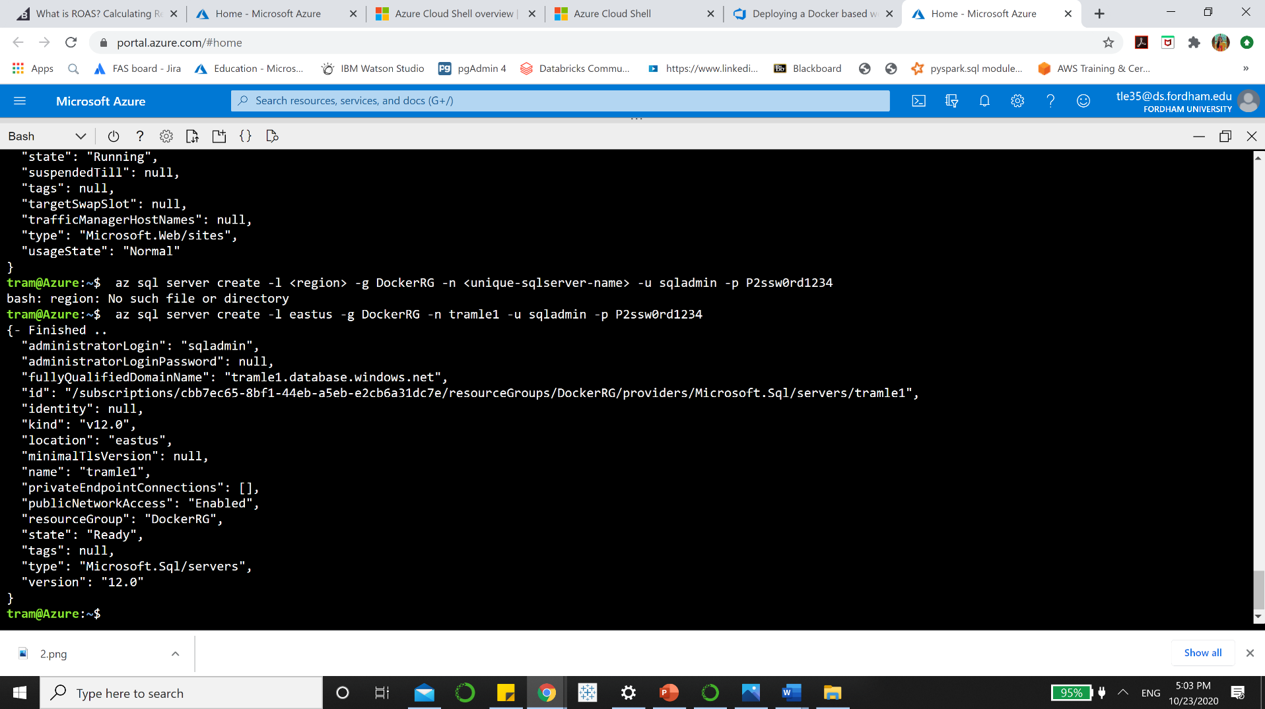

* Create a database

az sql db create -g DockerRG -s **<unique-sqlserver-name>** -n mhcdb --service-objective S0

Important: Enter a unique SQL server name. Since the Azure SQL Server name does not support UPPER / Camel casing naming conventions, use lowercase for the DB Server Name field value.

Change your <unique-sqlserver-name> to the previous name you choose.

az sql db create -g DockerRG -s **tramle1** -n mhcdb --service-objective S0

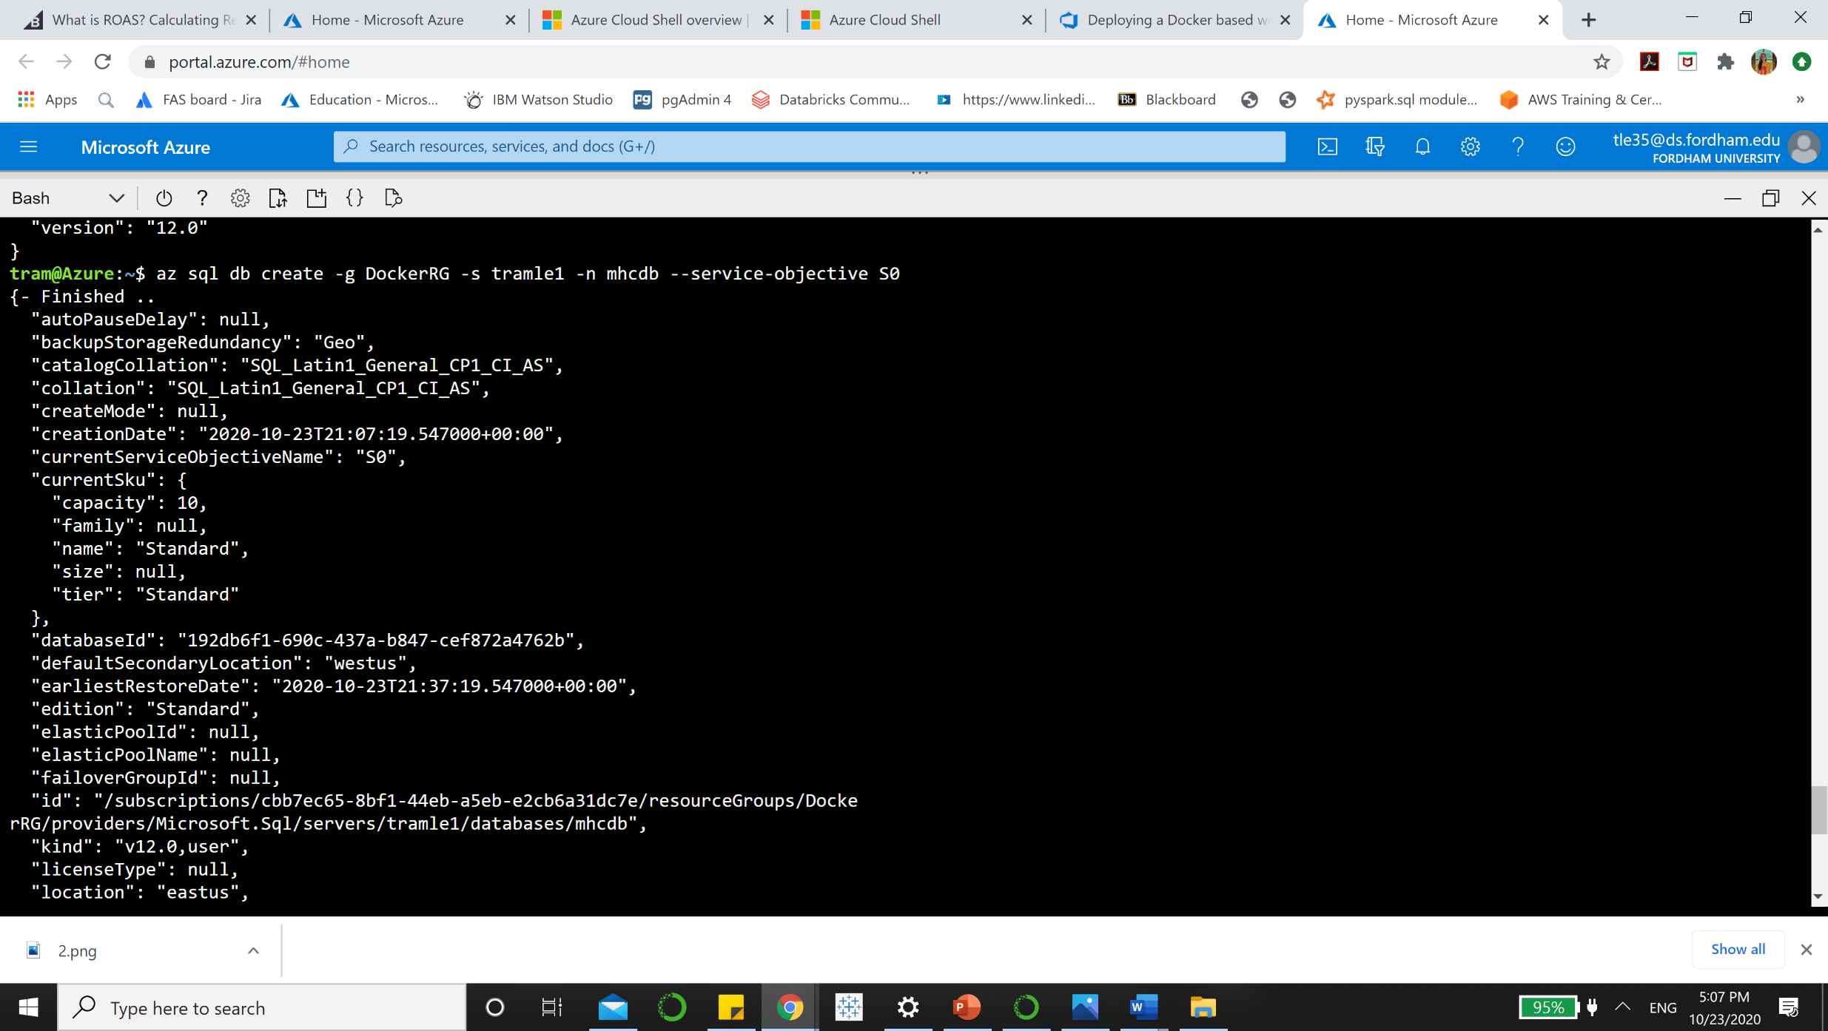

**Step 5: Create a firewall rule for SQL server that allows access from Azure services**

az sql server firewall-rule create --resource-group DockerRG --server **<your-sqlserver-name>** --name AllowAllAzureIps --start-ip-address 0.0.0.0 --end-ip-address 0.0.0.0

You should change <your-sqlserver-name> into your previous sql server name. For example, I would enter my sql server name in this command as tramle1.

az sql server firewall-rule create --resource-group DockerRG --server **tramle1** --name AllowAllAzureIps --start-ip-address 0.0.0.0 --end-ip-address 0.0.0.0

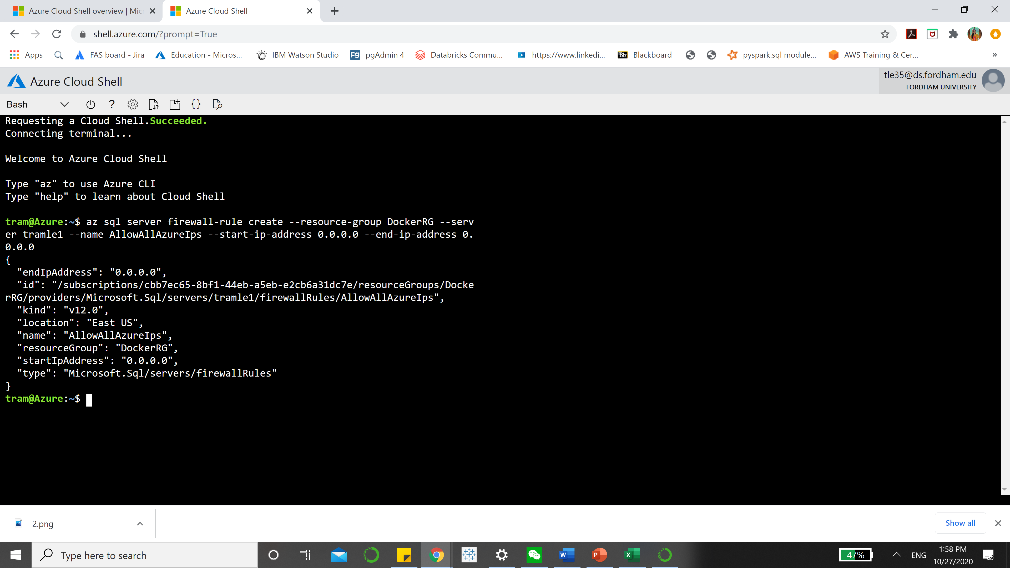

**Step 6: Update web app’s connection string**

az webapp config connection-string set -g DockerRG -n **<your-appservice-name>** -t SQLAzure --settings defaultConnection='Data Source=tcp:**<your-sqlserver-name>**.database.windows.net,1433;Initial Catalog=mhcdb;User Id=sqladmin;Password=P2ssw0rd1234;'

Update your app service name and SQL server name in the above command. This command will add a connection string to your app service with the name defaultConnection.

For example, my app service name is apptramle1 and my sql server name is tramle1, I will enter it as:

az webapp config connection-string set -g DockerRG -n **apptramle1(BidDataApp)** -t SQLAzure --settings defaultConnection='Data Source=tcp:**tramle1**.database.windows.net,1433;Initial Catalog=mhcdb;User Id=sqladmin;Password=P2ssw0rd1234;'

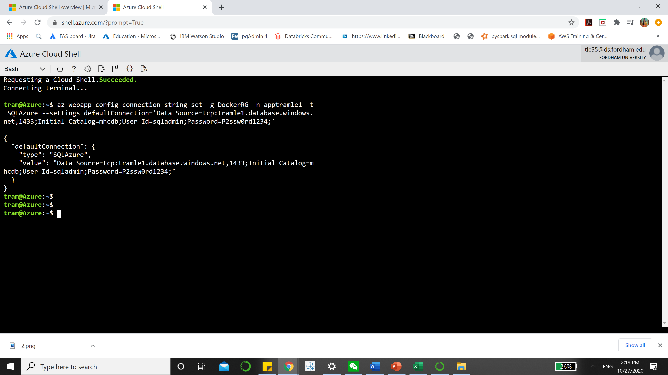

**Step 7: Navigate to the resource group. You can see the following components are provisioned**

Now go to Azure Portal <https://portal.azure.com/#home>. Click on the Menu icon then choose **Resource groups**

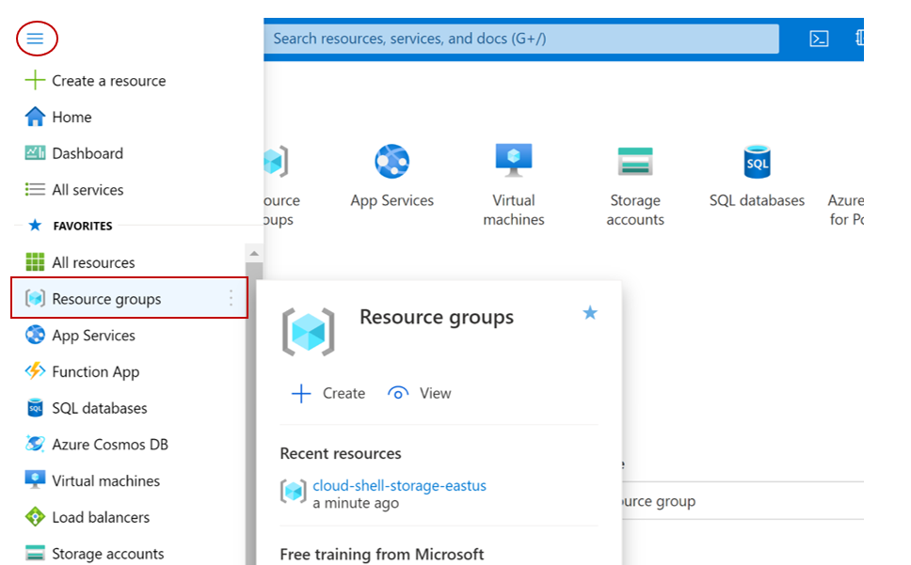

Now click on DockerRG in the Resource Groups window. You will see your systems are updated.

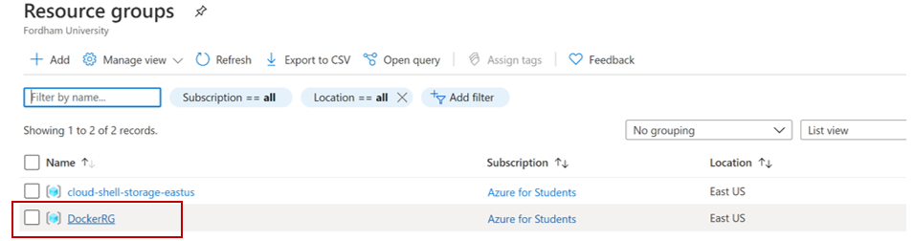

Now, you should see your updated systems

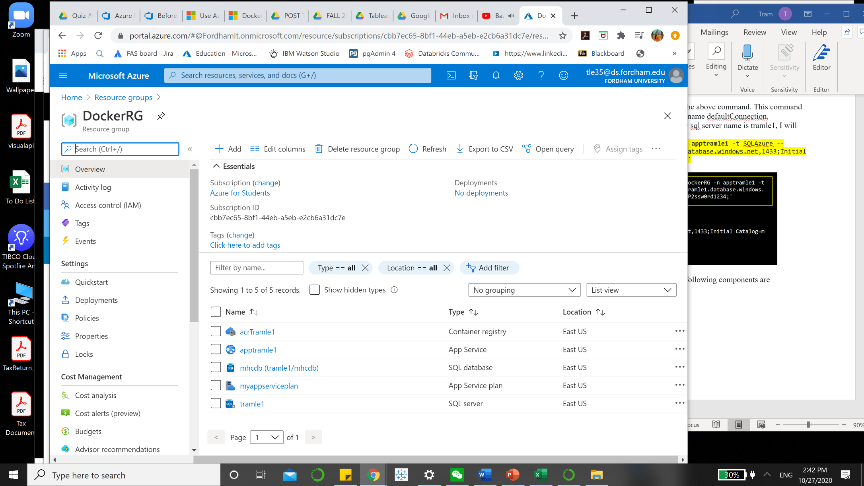

For your information, here is some explanation on the different types of services:

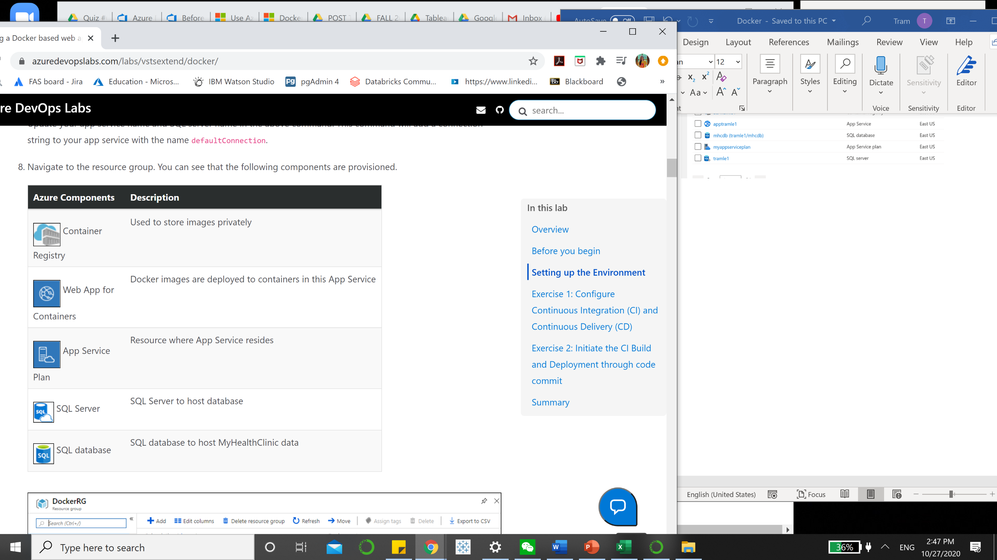

**Step 8: Make note of the server details under the header Server name**

Click on the **mhcdb** SQL database and make a note of the server details under the header **Server name**.

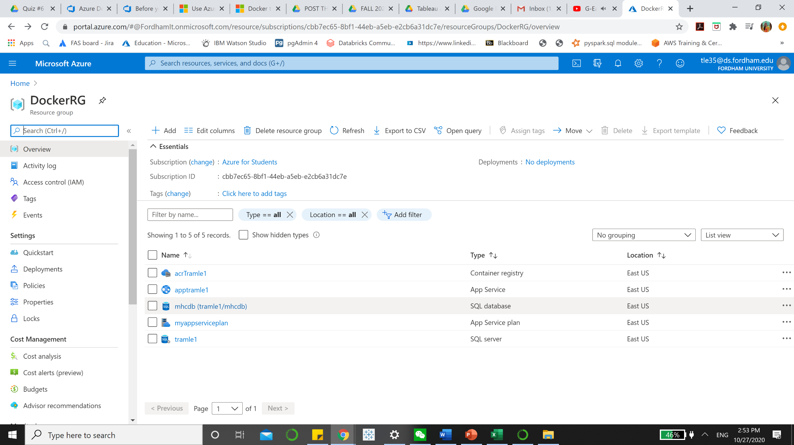

You will see this window and take note of your server name: yoursqlservername.**database.windows.net**

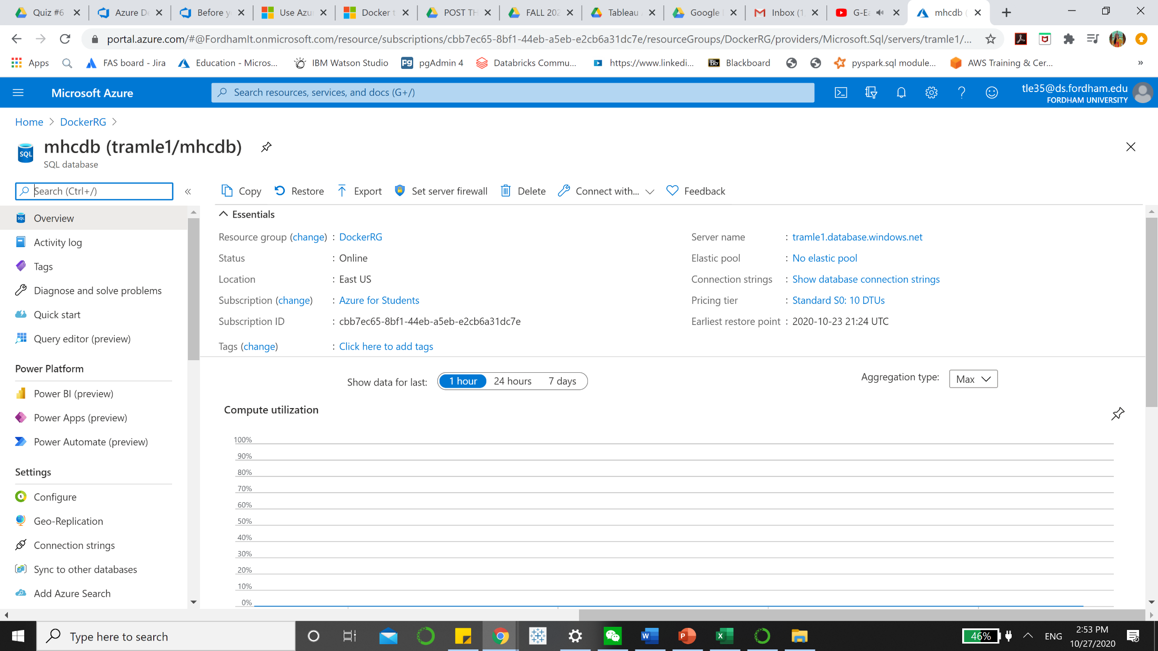

**Step 9: Make a note of server details under the header Login Server in Container Registry**

Navigate back to the resource group. Click on the container registry and make a note of the server details under the header Login server. These details will be required in the Exercise 2.

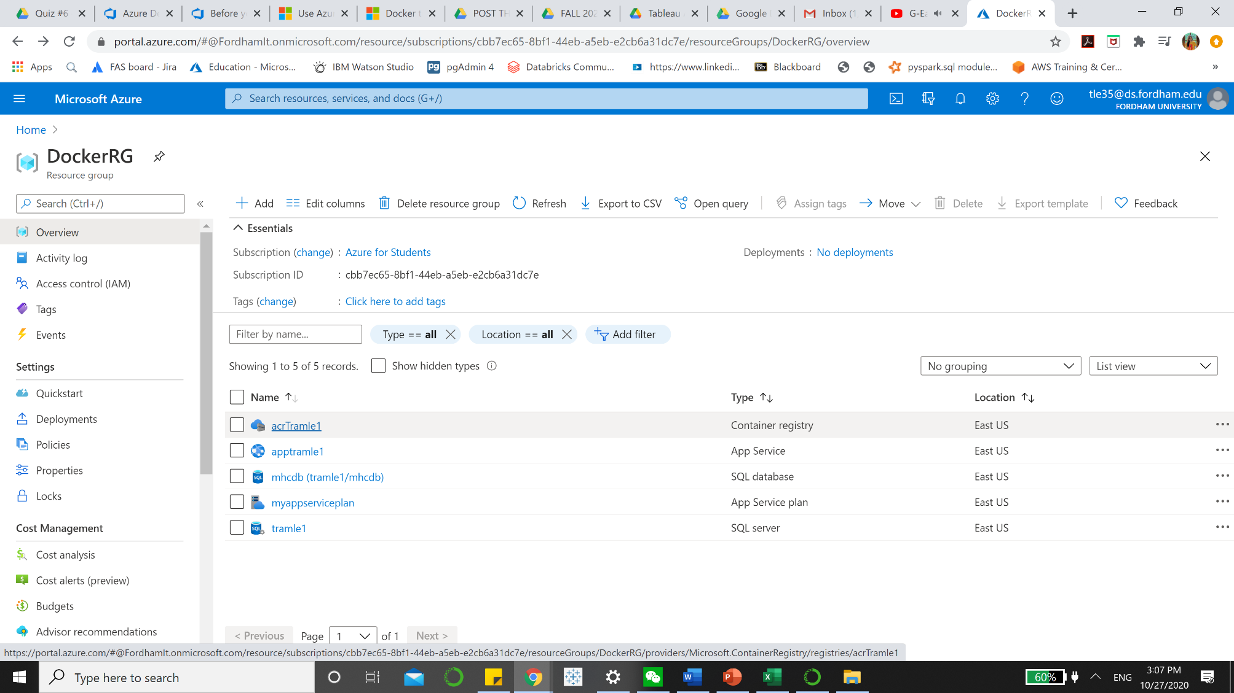

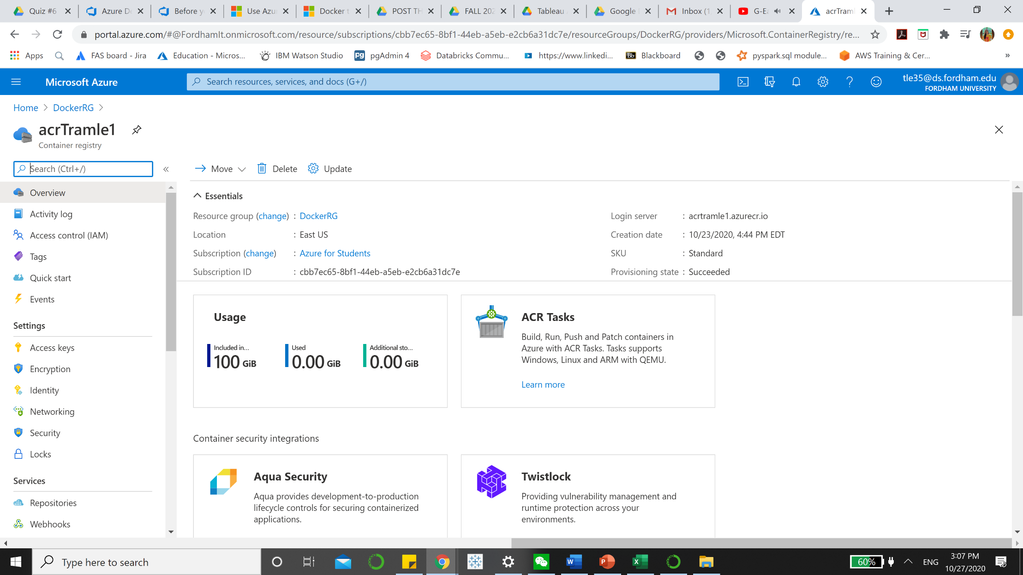

# Exercise 1: Configure Continuous Integration (CI) and Continuous Delivery (CD)

Now that the required resources are provisioned, the Build and the Release definition need to be manually configured with the new information. The dacpac will also be deployed to the mhcdb database so that the schema and data is configured for the backend.

Go to <https://docs.microsoft.com/en-us/azure/devops/get-started/?view=azure-devops> and choose **Open Azure DevOps** in the right corner and log in with your Azure DevOps account.

Or you can go to [https://**dev.azure.com**](https://dev.azure.com) and log in

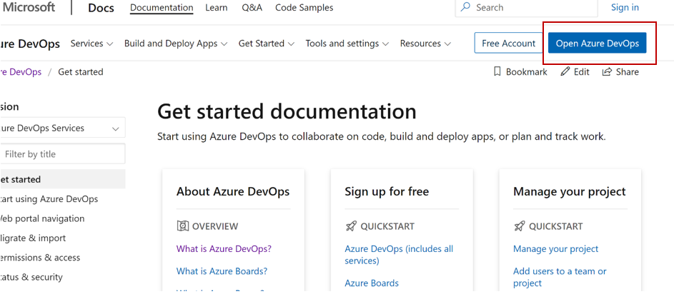

Then choose your project name **Docker (Generated by Azure DevOps Demo Generator)** in your window

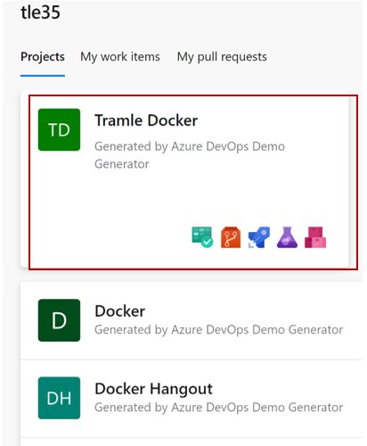

**Step 1:**  In the Menu panel, choose **Pipelines > Pipelines > MHCDocker.Build** then click **edit**

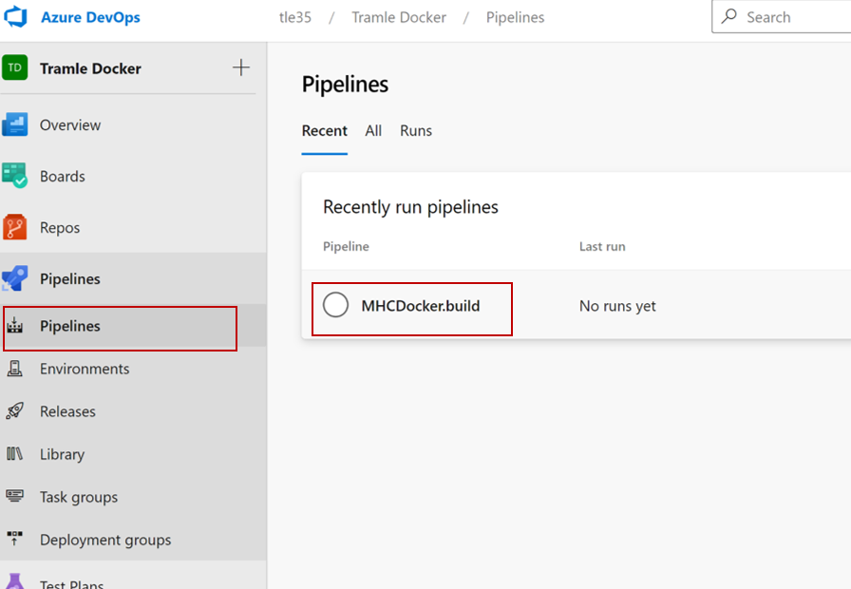

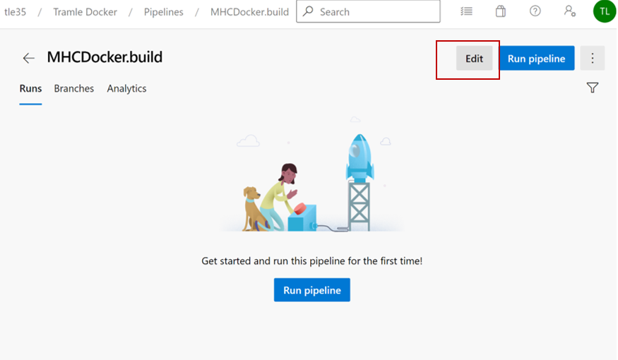

**Step 2**: In the **Run services, Build services and Push services** tasks, authorize (only for the first task) the **Azure subscription** (choose **Azure for** Student) then click **Authorize.**

For Run Services: choose Azure Subscription

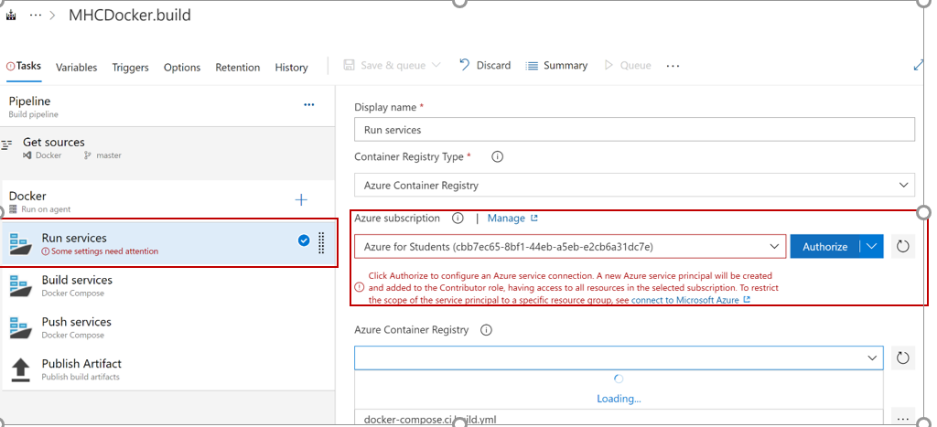

Then update **Azure Container Registry** with the endpoint component from the dropdown and click on **Save.**

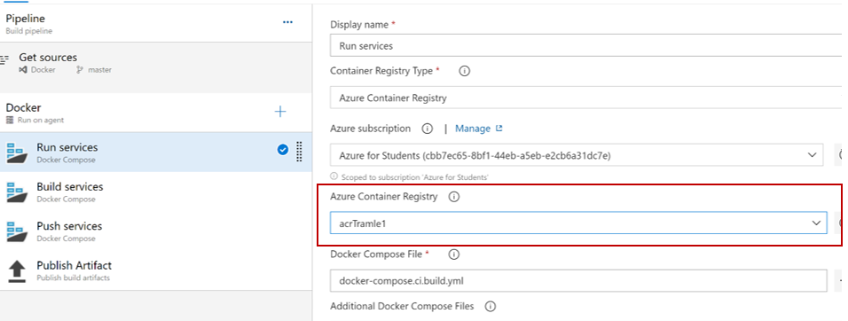

For Build Services:

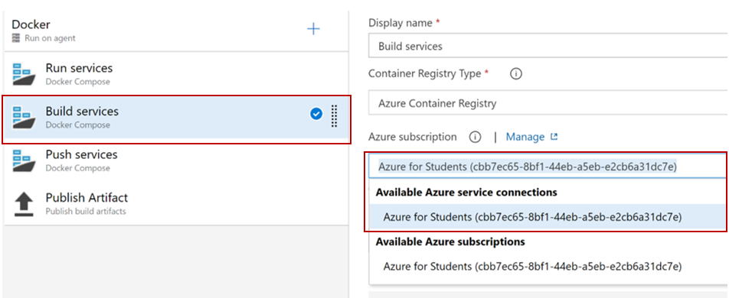

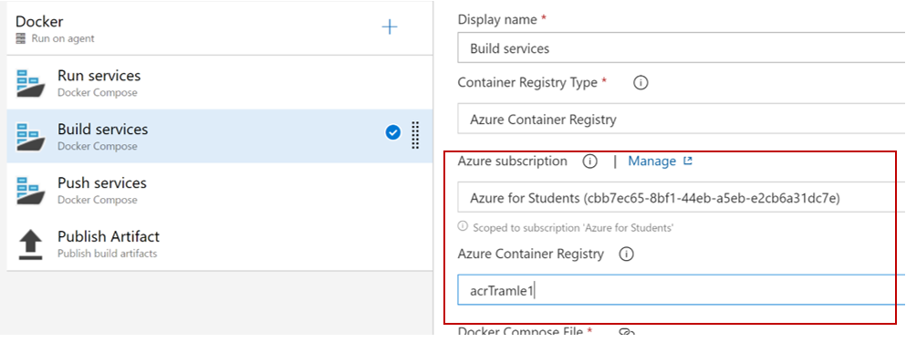

For Push Services (choose **Available Azure Service Connections** like Build Services in **Azure Subscription)**:

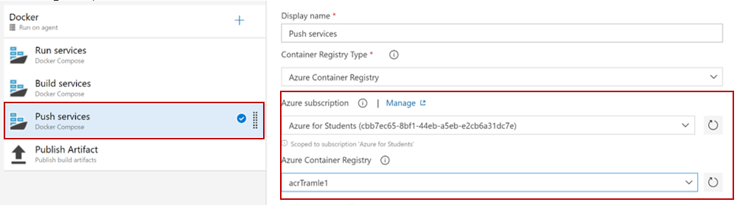

Now, click on **Save & queue** and choose **Save**

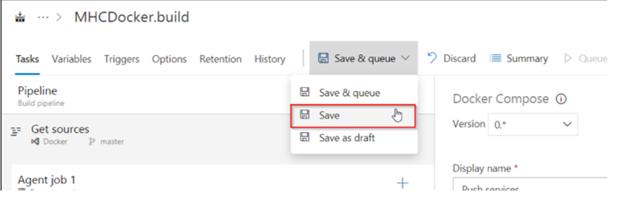

**Run services**: Prepares suitable environment by restoring the required packages

**Build services**: builds **myhealth.web** image

**Push services**: push **myhealth.web** image tagged with **$(Build.Buildld)** to container registry

**Publish Build:** used to share dacpac for database deployment through Azure DevOps artifacts

**Step 3**: Navigate to the **Releases** section under the **Pipelines** tab. Select the release definition MHCDocker.release, click **Edit** option then click on the **Tasks** section

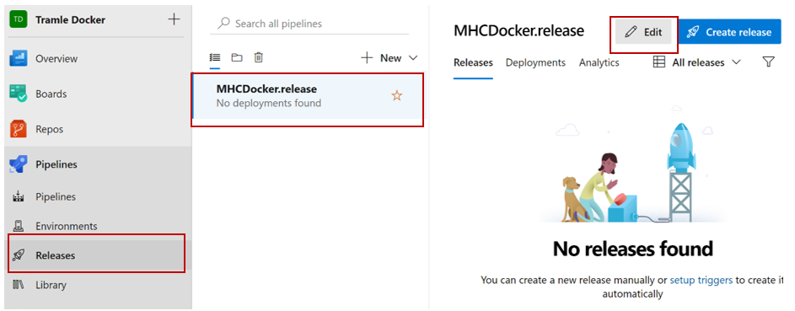

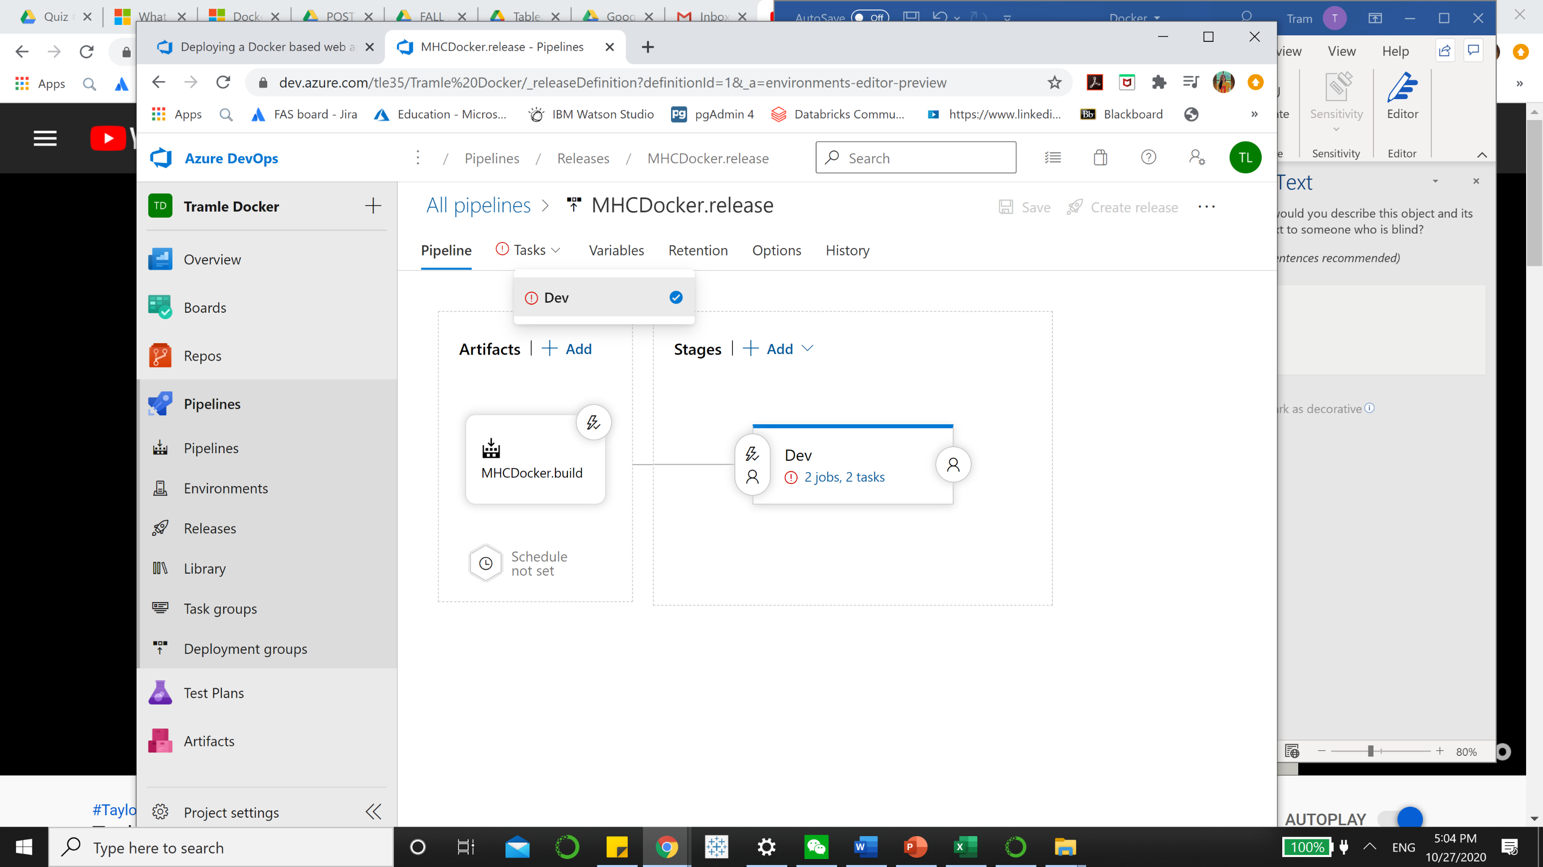

**Step 4**: The usage details of the agents are provided below:

| **Agents** | **Usage Details** |
| --- | --- |
| **DB deployment** | The **Hosted VS2017** agent is used to deploy the database |
| **Web App deployment** | The **Hosted Ubuntu 1604** agent is used to deploy the application to the Linux Web App |

**Step 5**: Under the **Execute Azure SQL: DacpacTask** section, select the **Azure Subscription** from the dropdown.

**Execute Azure SQL: DacpacTask:** This task will deploy the dacpac to the mhcdb database so that the schema and data are configured for the backend.

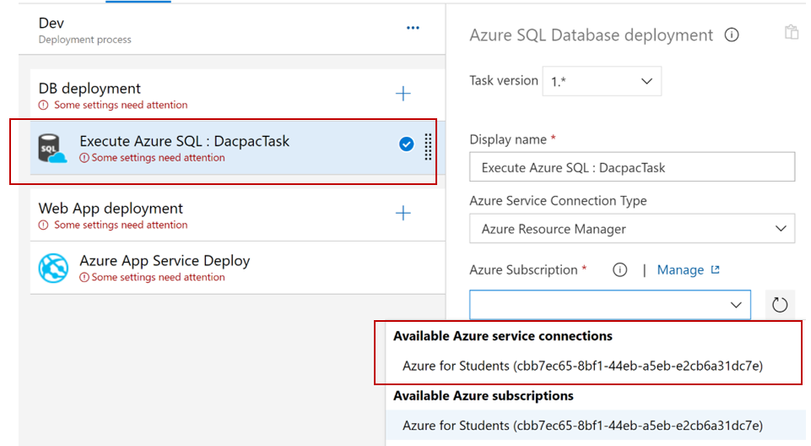

**Step 6**: Under **Azure App Service Deploy** task, update the **Azure subscription** and **Azure App** **Service name** with the endpoint components from the dropdown.

**Azure App Service Deploy** will pull the appropriate docker image corresponding to the BuildID from repository specified, and then deploys the image to the Linux App Service.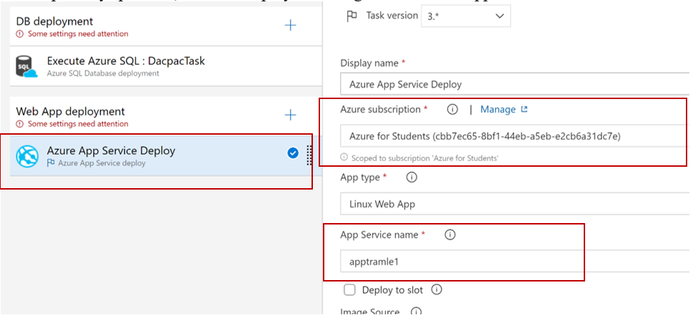

**Step 7**: Set up DB deployment and Web App deployment. For **DB deployment**

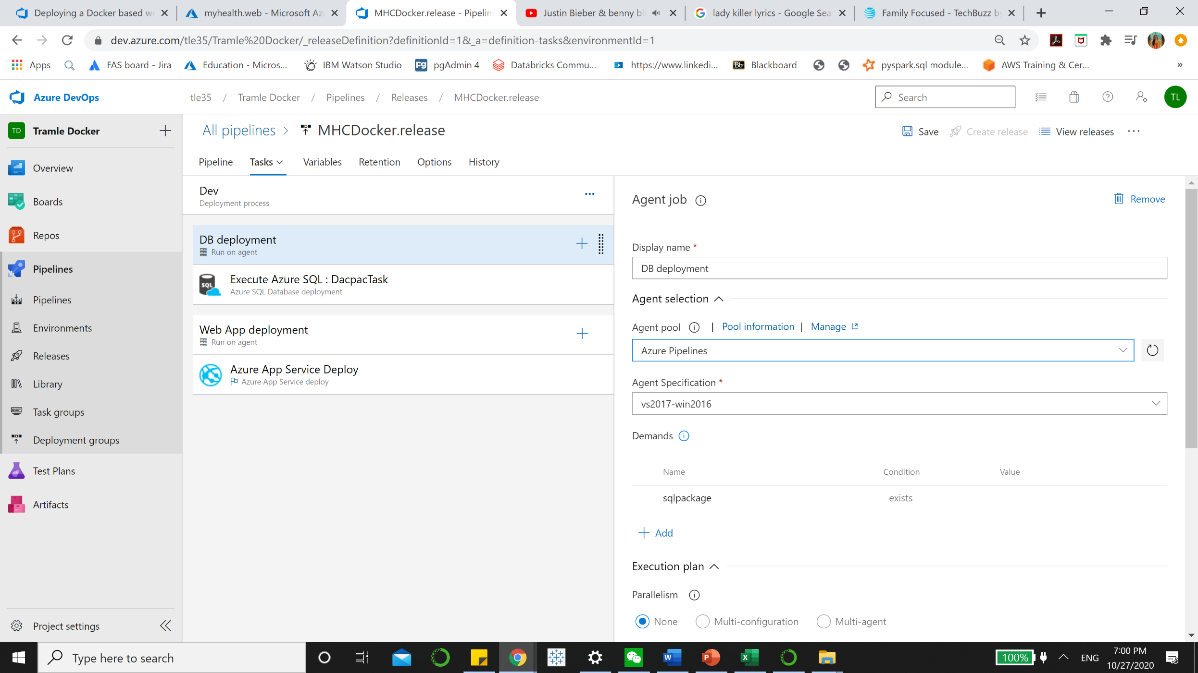

For **Web App Deployment**,

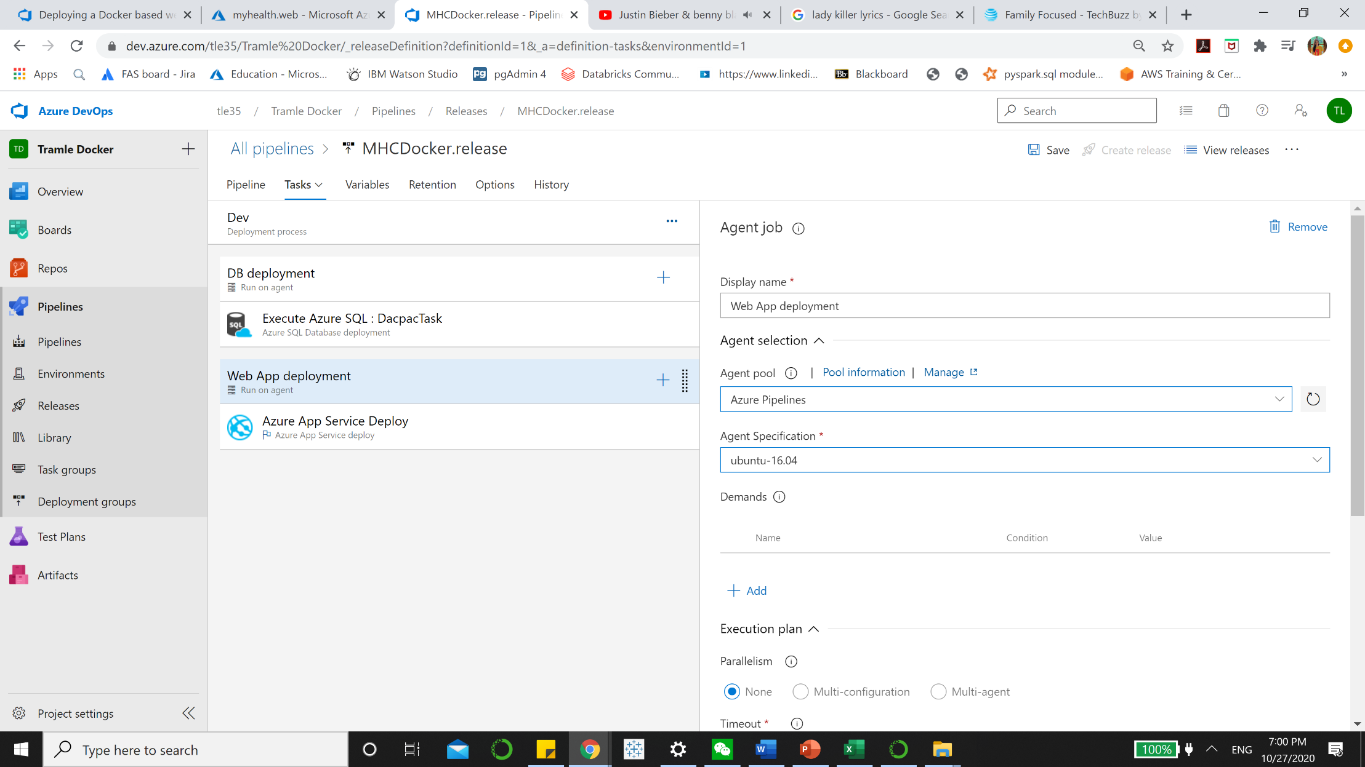

**Step 8:** Click on the **Variables** section, update the **ACR** details and the **SQLserver** details with the details noted earlier while the configuration of the environment and click on the **Save** button.

The **Database Name** is set to **mhcdb**, **the Server Admin Login** is set to **sqladmin** and the **Password** is set currently to **P2ssw0rd1234.**

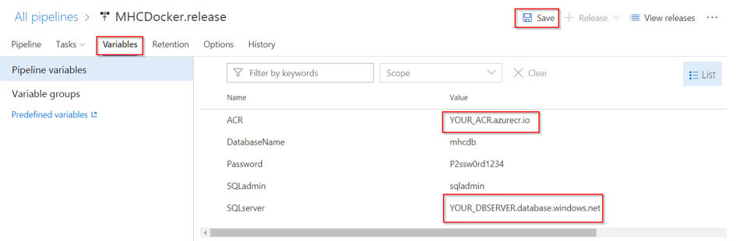

For example, my set up would be:

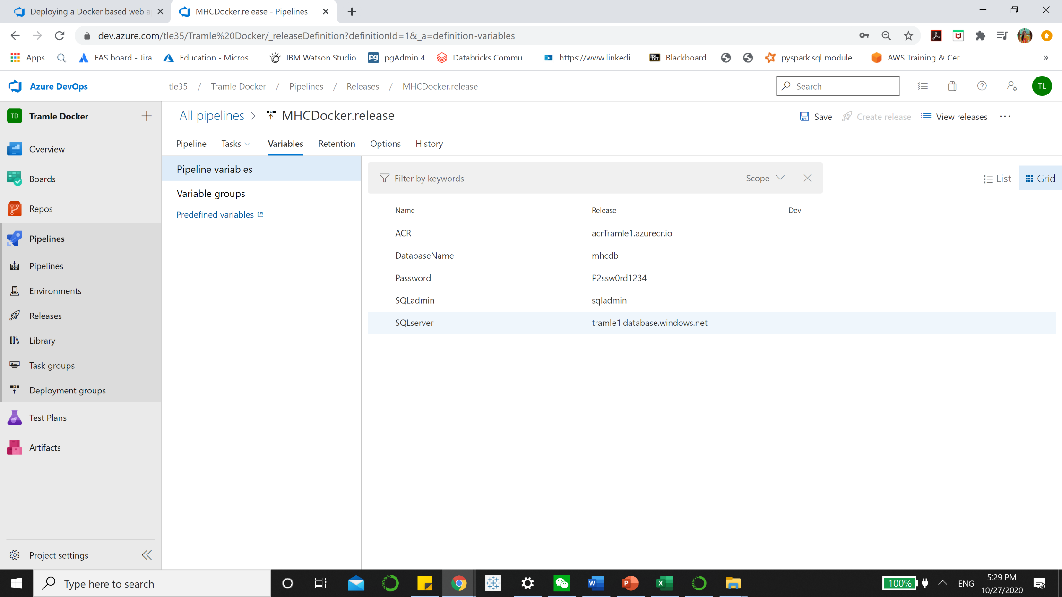

# Exercise 2: Initiate the CI Build and Deployment through code commit

In this exercise, the source code will be modified to trigger the CI-CD

**Step 1:** Click on **Files** section under the **Repos** tab, and navigate to the Docker/src/MyHealth.Web/Views/Home folder and open the Index.cshtml file for editing.

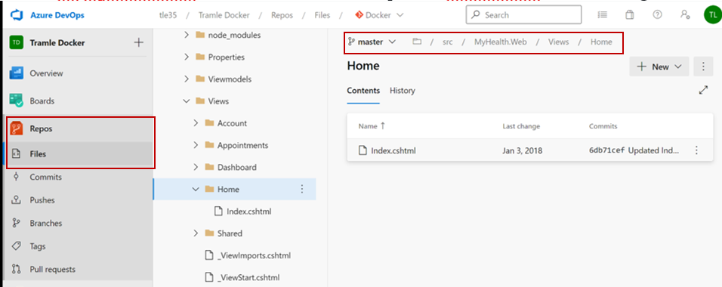

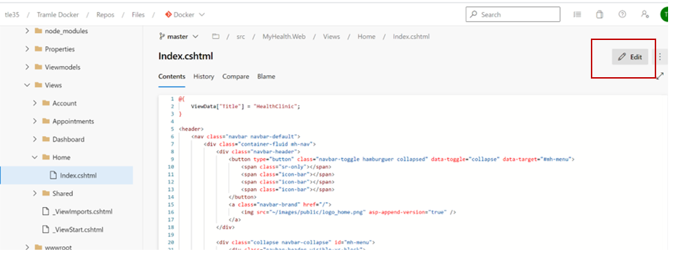

**Step 2**: Modify the text **JOIN US** to **CONTACT US** on the **line number 28** and then click on the **Commit** button. This action would initiate an automatic build for the source code.

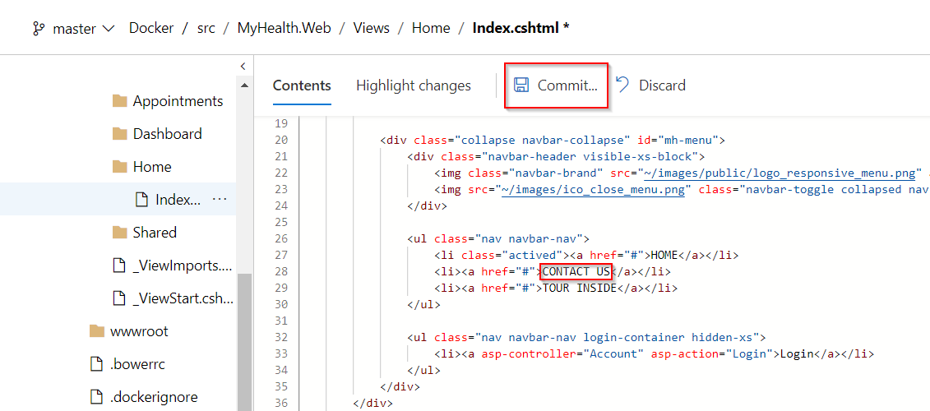

**Step 3:** Click on **Pipelines** tab, you will see MHCDoker.build is updated. Double click on MHCDocker.build to see the progress

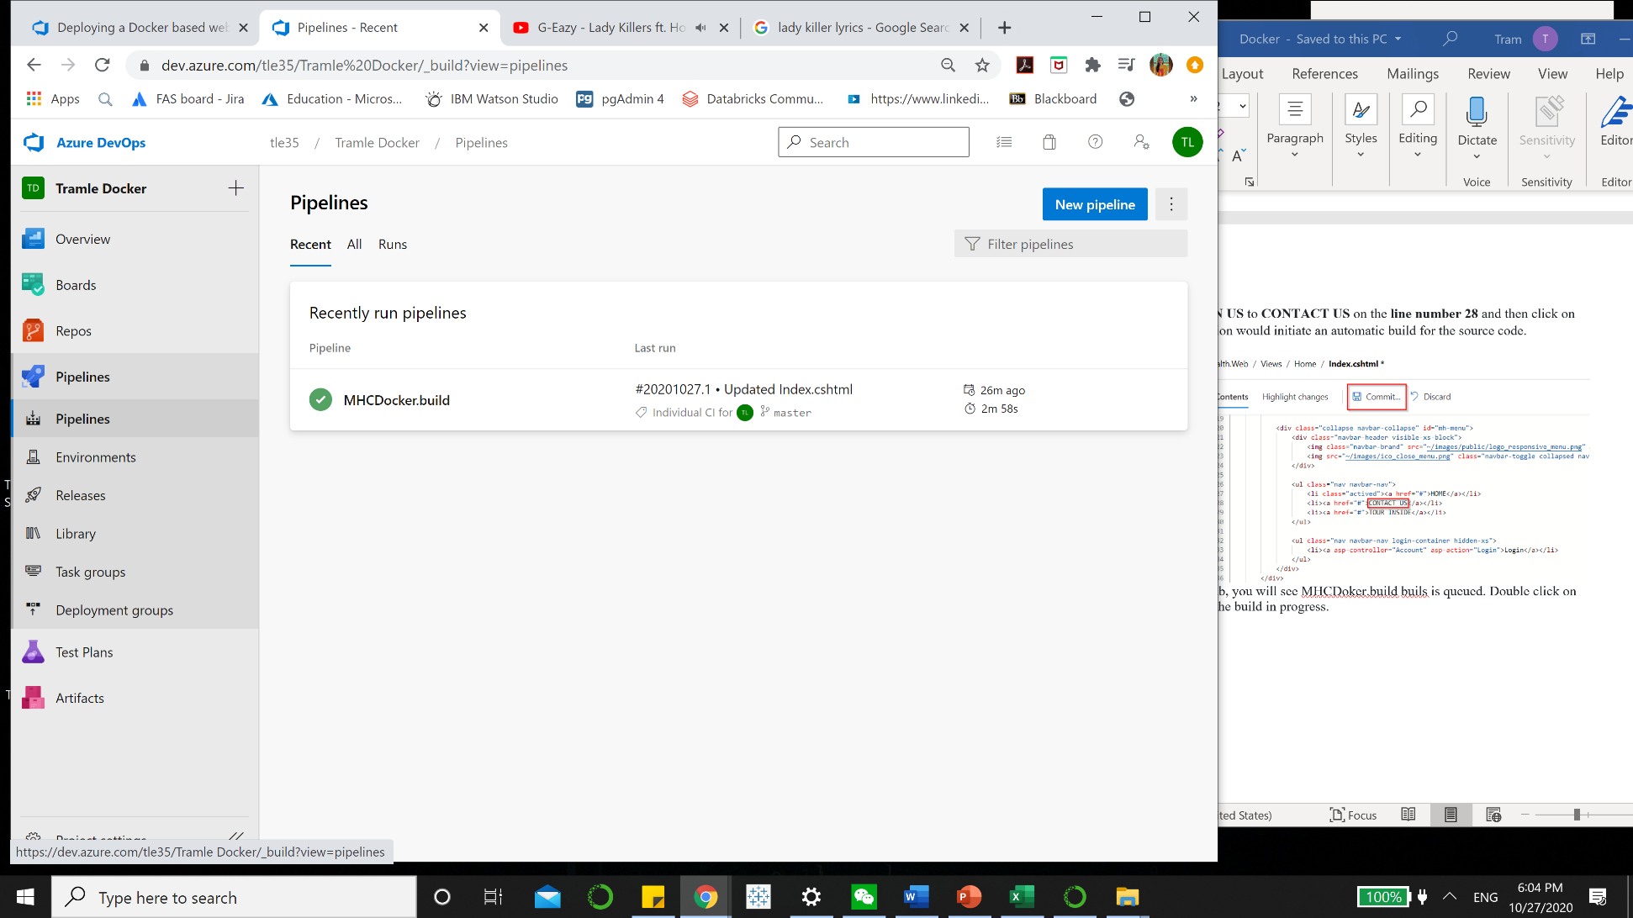

You can double click on Docker to see the running progress

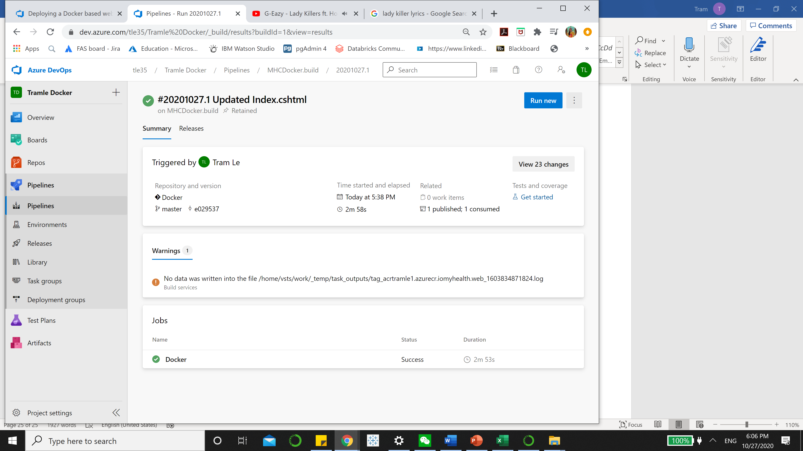

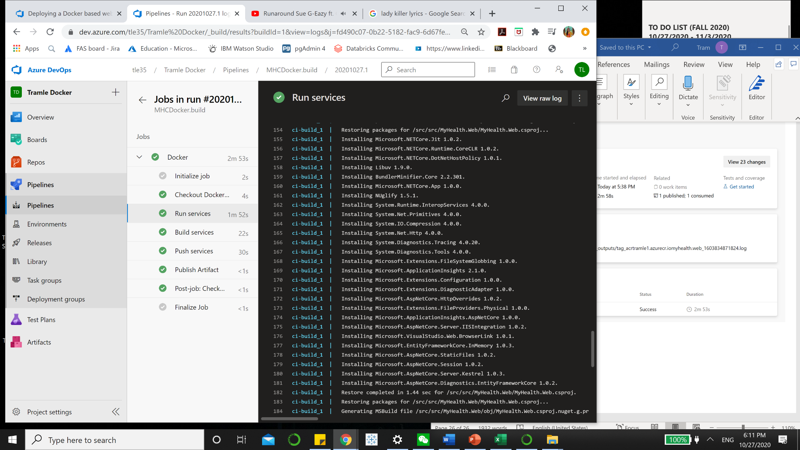

**Step 4**: Go to [**Azure Portal**](https://portal.azure.com/) and click on the **App Service** that was created at the beginning of the lab. Select the **Container Settings** option and provide the information as suggested and then click the **Save** button

| **Field** | **Value to be provided** |
| --- | --- |
| **Image Source** | Select the value **Azure Container Registry** |
| **Registry** | Select the registry value from the dropdown |
| **image** | Select the value **myhealth.web** |
| **Tag** | Select the value **latest**. This is required to map Azure Container Registry with the Web App. |

In the **Menu** panel of Azure portal, choose **Resource groups > DockerRG > Overview > yourappservice name**

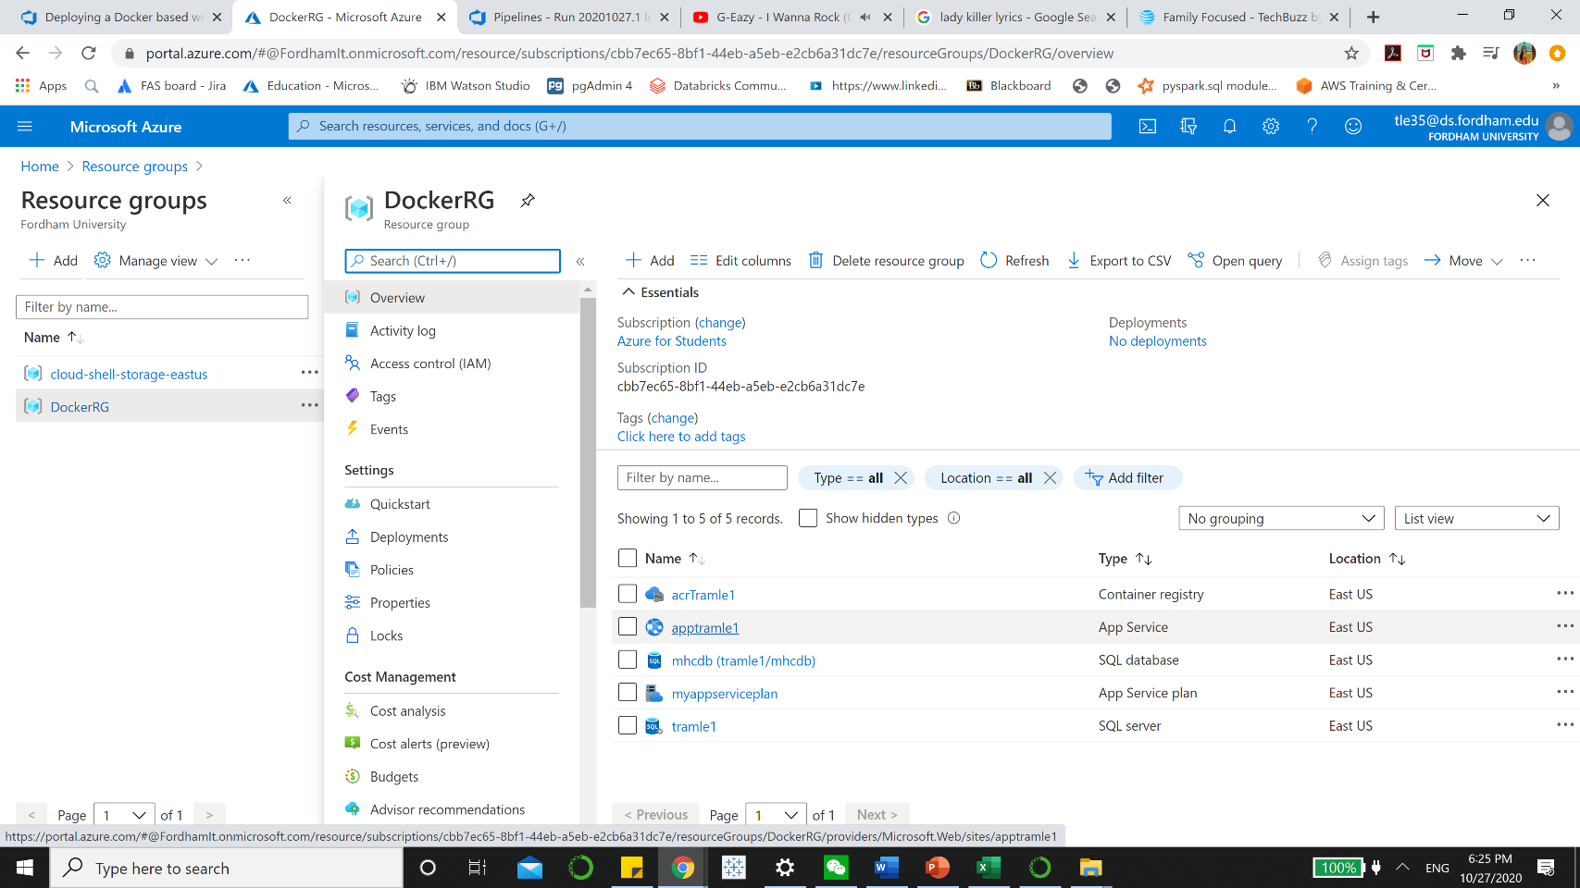

Now on the menu penal, select **Container Settings** under **Setting**

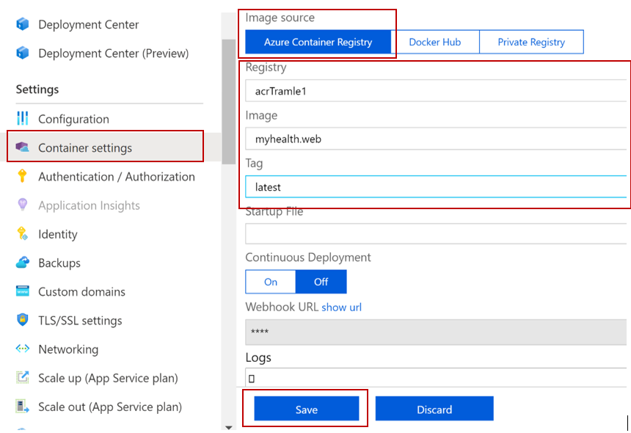

**Step 5:** Navigateto the **Azure Container registry** created and then select **Repositories** option to view the generated docker images

Go to **Resource Groups > DockerRG > your Container registry**

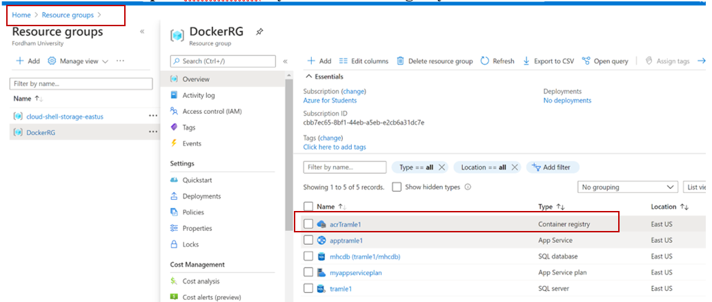

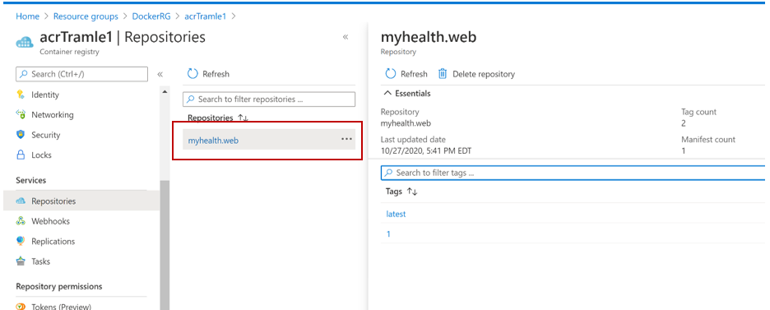

**Step 6:** Navigate to the **Releases** section under **Pipelines** tab, and double-click on the latest release displayed on the page or click the words **Deploy** under **Stage Dev** (hoover your mouse under Dev in States). Click on **Logs** to view the details of the release in progress.

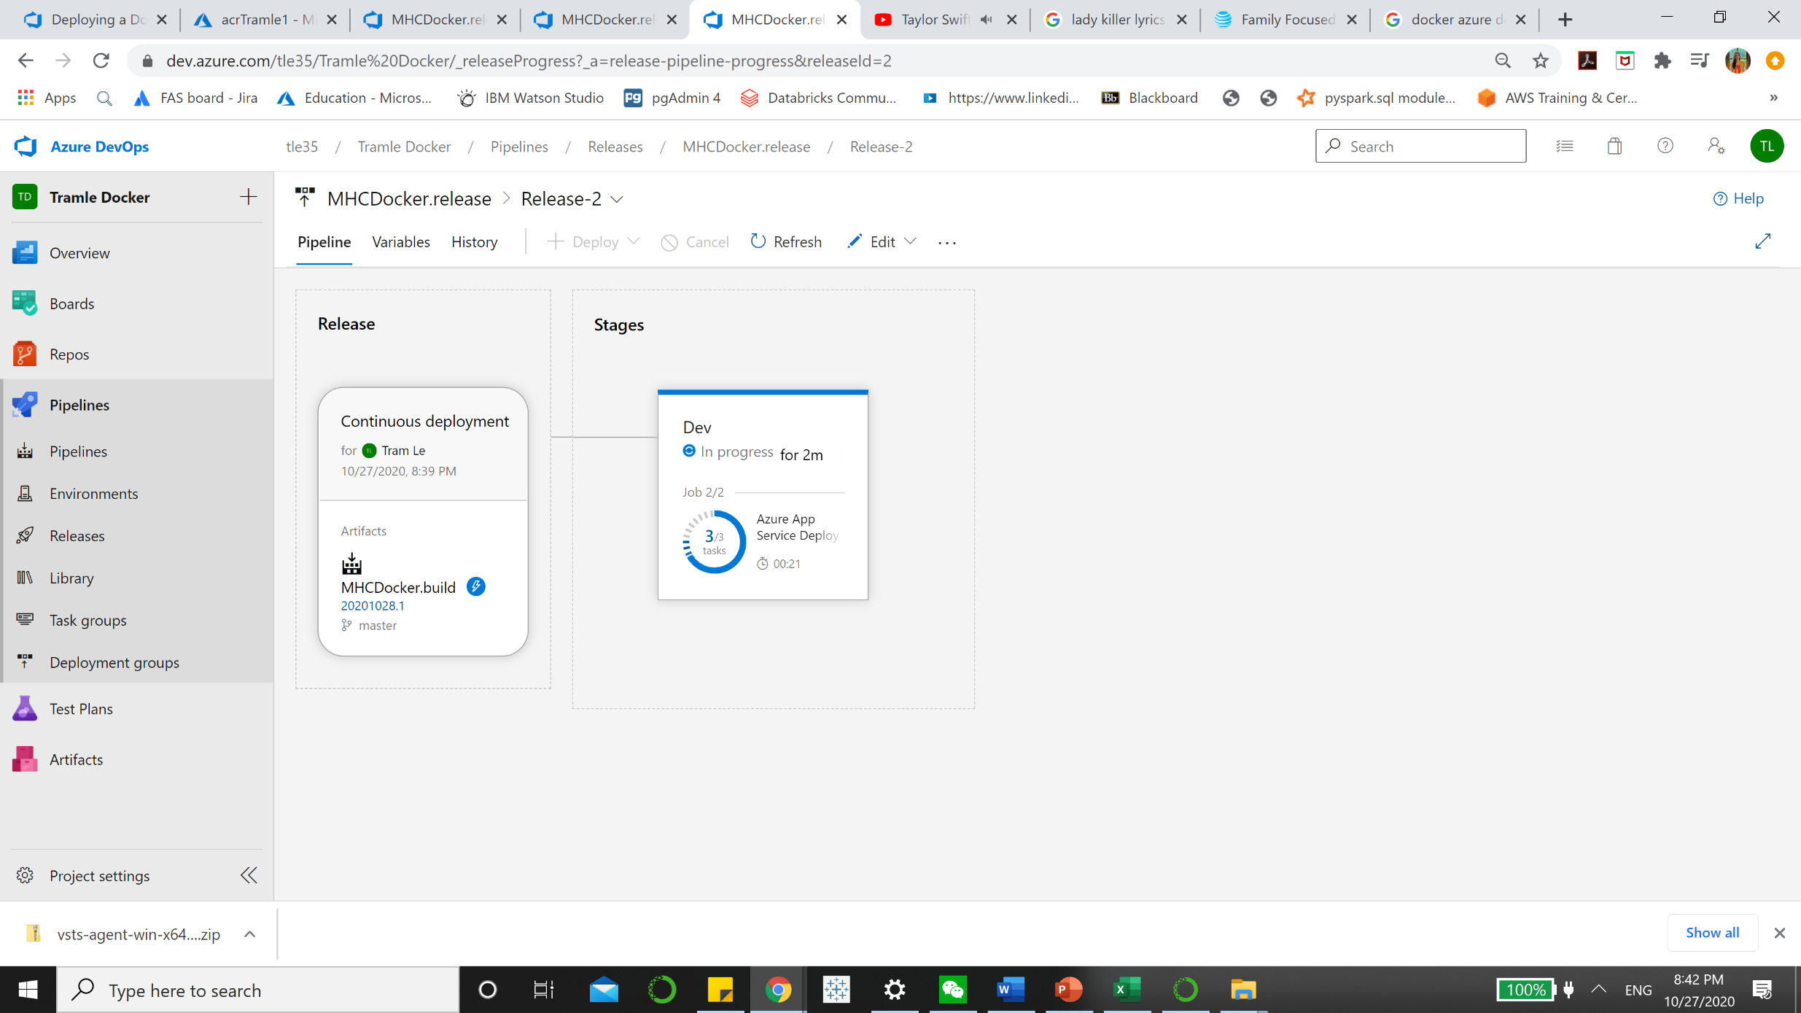

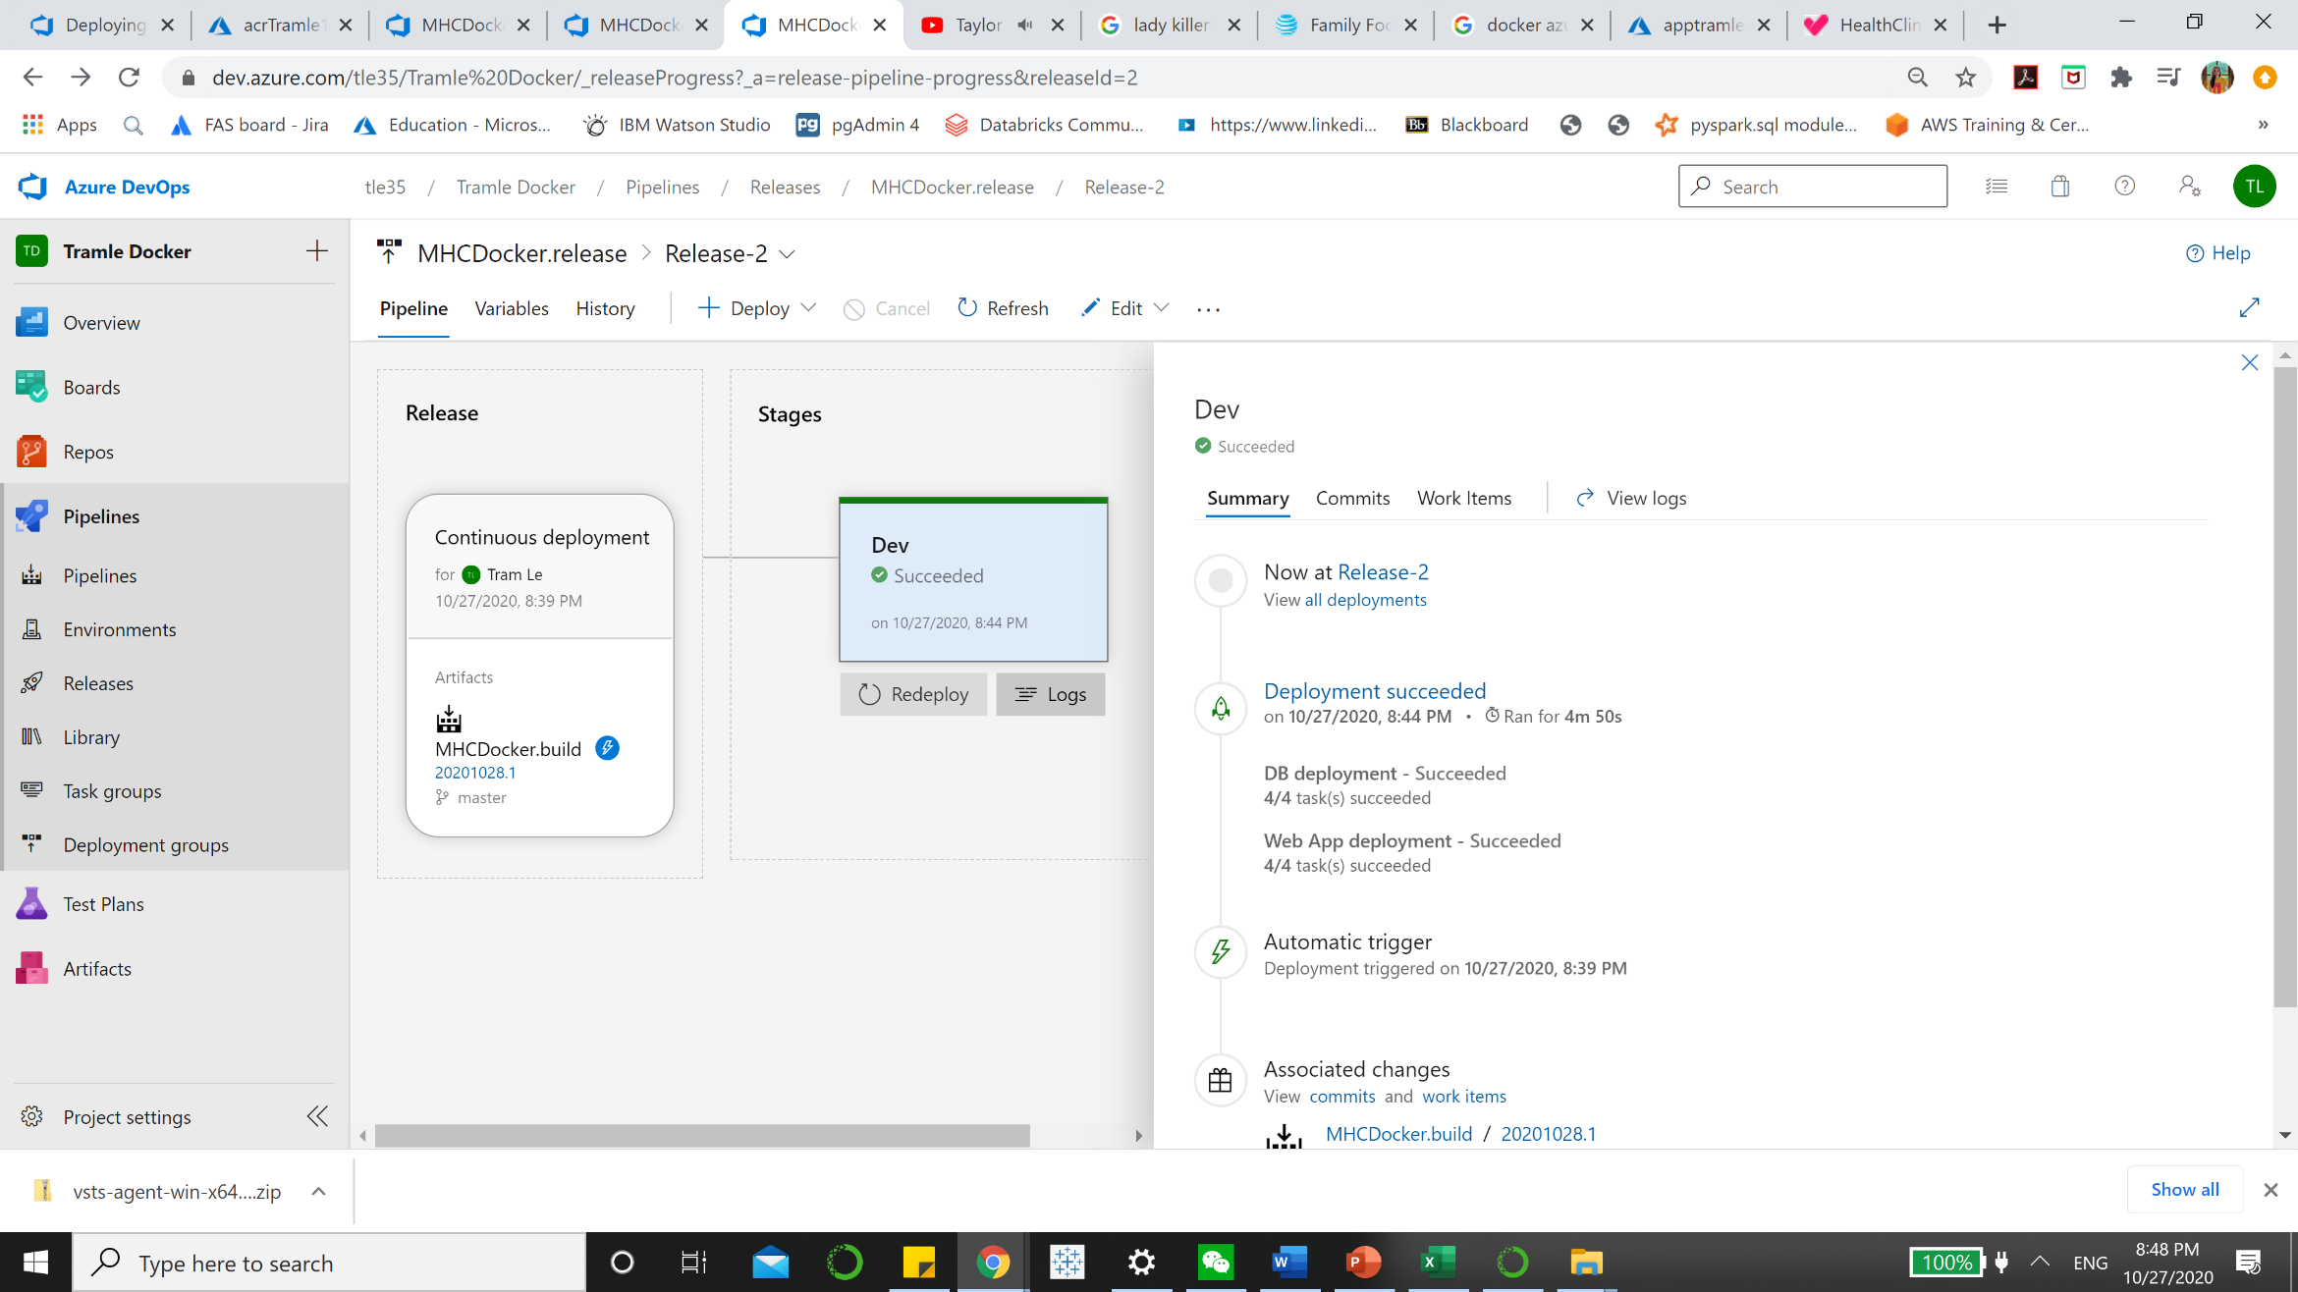

**Step 7:** The release will deploy the docker image to the App Service based on the **BuildID** tagged with the docker image. Once the release is completed, the release **Logs** will be displayed.

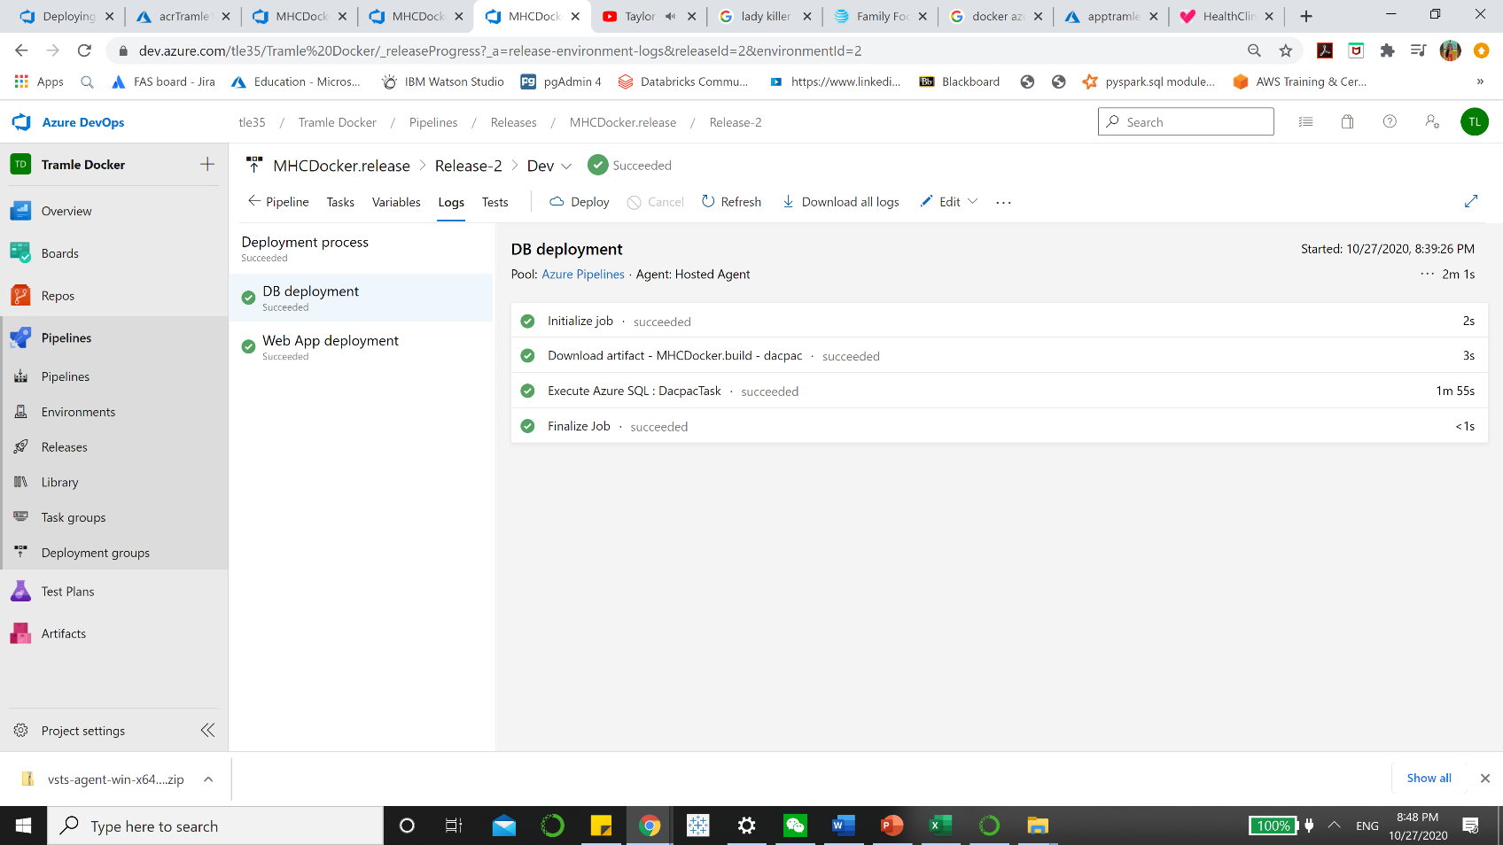

**Step 8:** Navigate back to the [Azure Portal](https://portal.azure.com/) and click on the **Overview** section of the **App Service**. Click on the link displayed under the **URL** field to browse the application and view the changes.

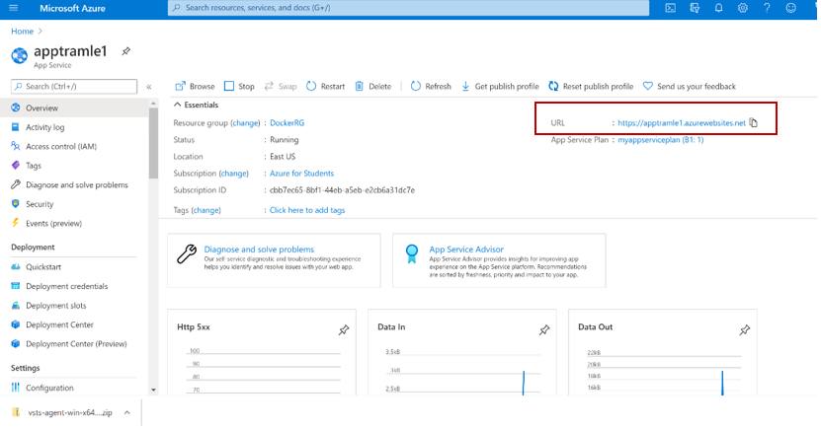

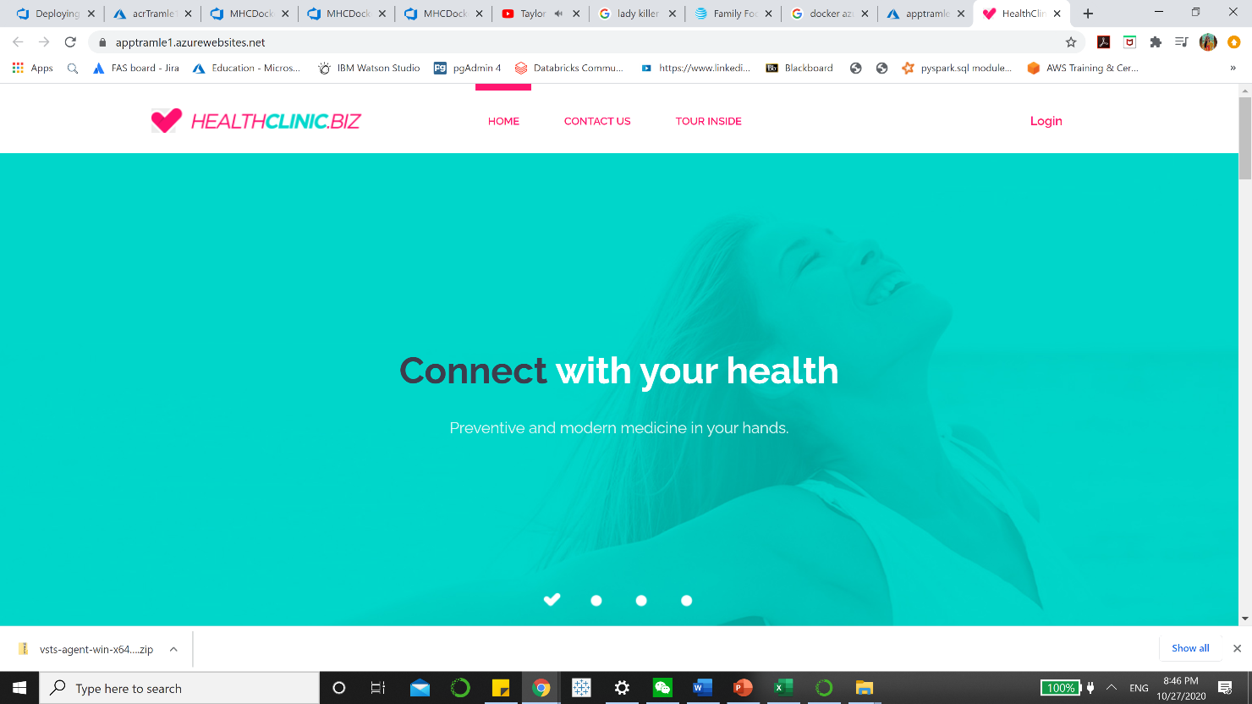

Step 10: Use the credentials **Username**: user and **Password**: P2ssw0rd@1 to login to the **HealthClinic** web application.